<https://blogs.perficient.com/2016/01/05/parallel-execution-of-tests-using-selenium-grid-and-testng/> set up hub

<http://www.tothenew.com/blog/parallel-execution-with-selenium-grid/>

* Selenium IDE – Integrated Development Environment (2004), It is record and playback tool, It only support Firefox browser.
* Selenium RC 1.0 -Remote control server, it is program oriented tool, it supports the entire browser, but fail to support rich API.
* Selenium Web driver 2.0 - It supports the entire browser, and support Windows, Linux, OSX, solaris OS’S
* It support 6 languages
* Java, C#, Python, Perl, Ruby, PHP
* We can use any language without considering web application developed language.
* Using this we can test mobile and web based application.
* RC not supports mobile web application.
* We can use same code in desktop browser and mobile browser testing with some additional packages in web driver.
* Left side eclipse editor, intermediate selenium rc, right side browser.

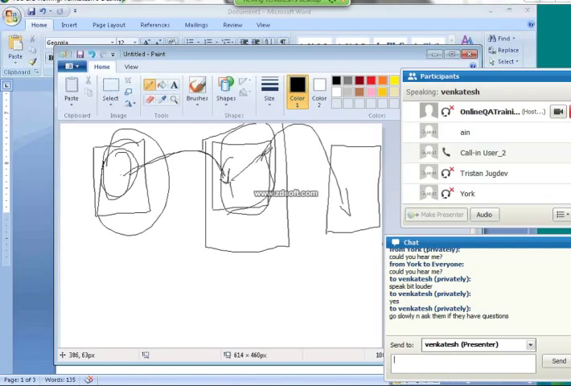

* Web driver directly communicate to browser without setting any internal proxy, so the speed of the execution is fast.
* RC required cmd command to start server before start test script execution. And we need stop the server after test script execution.
* Web driver not required any command to start and stop server.

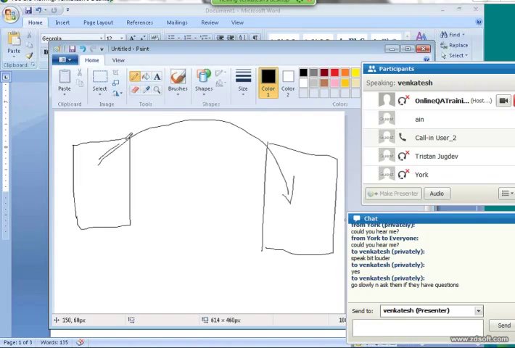

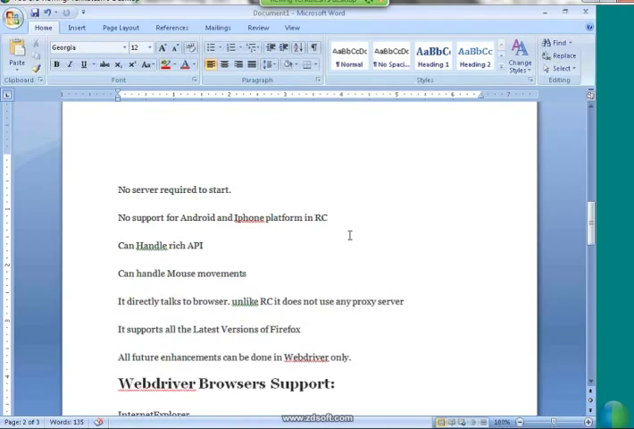

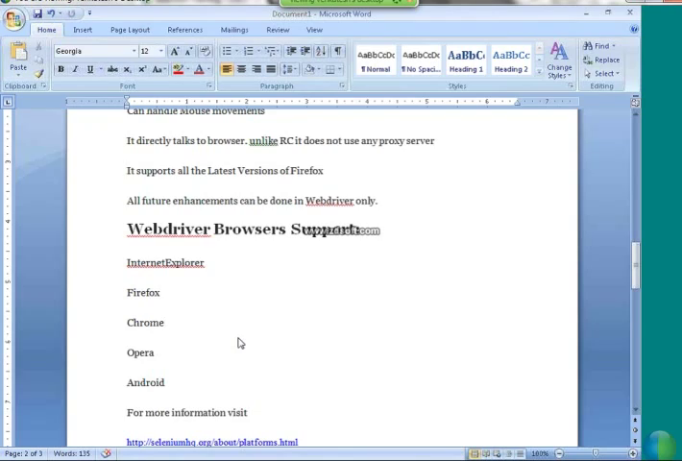

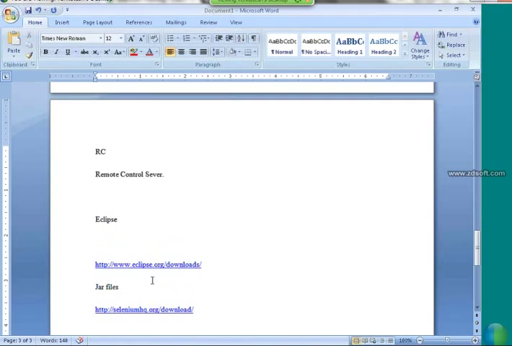

* Flow of creating new project/test suite

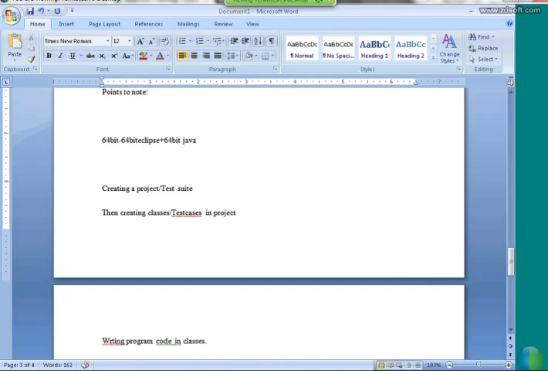

* Screenshot for create new class

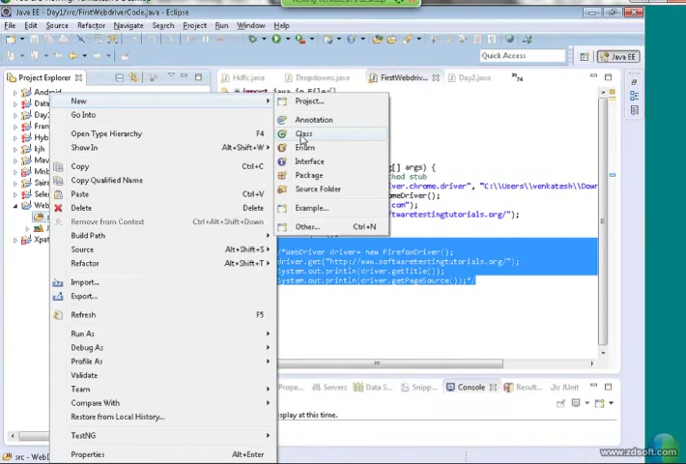

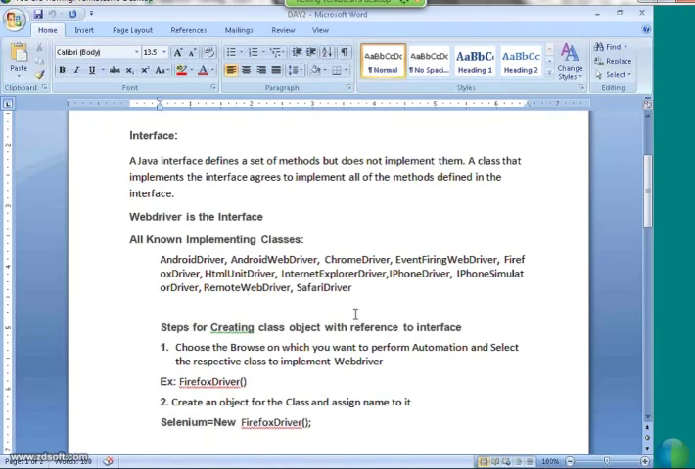

* WebDriver driver=**new** FirefoxDriver(); //create WebDriver object

driver.get("http://google.com"); //get the url

System.***out***.println(driver.getTitle()); //display the tab title in console window

System.***out***.println(driver.getCurrentUrl()); //display currently running url in console window

driver.close(); //close only selenium running browser

* All interface variables are by nature static and final
* Interface should not have function body.
* Using implements keyword we can access interface class from another class.
* Class should have definition of method which is declared in interface class, if we inherit interface class.
* We can’t create object for interface class.
* webDriver is an interface.
* Firebug is using for inspect the webelement.

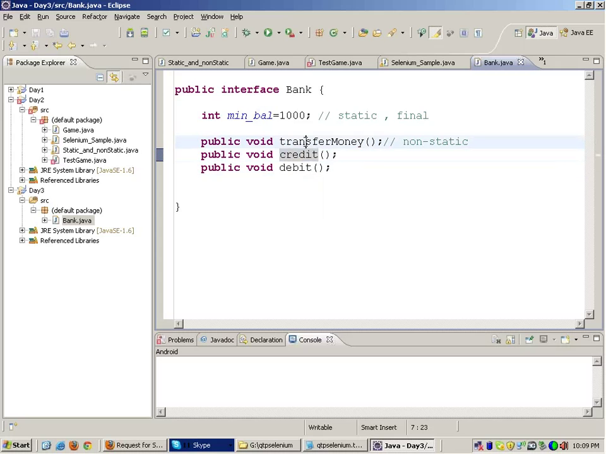

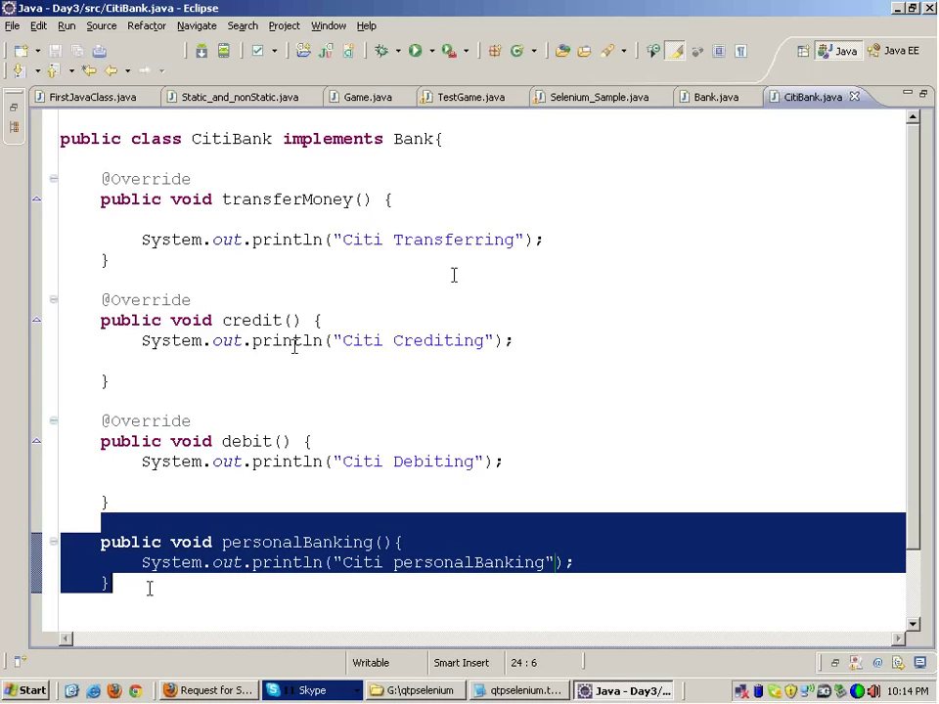

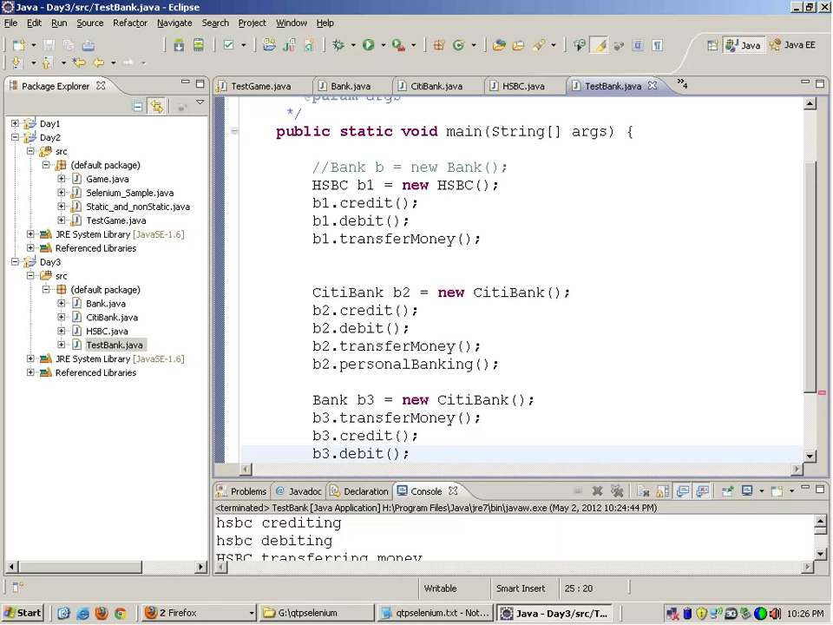

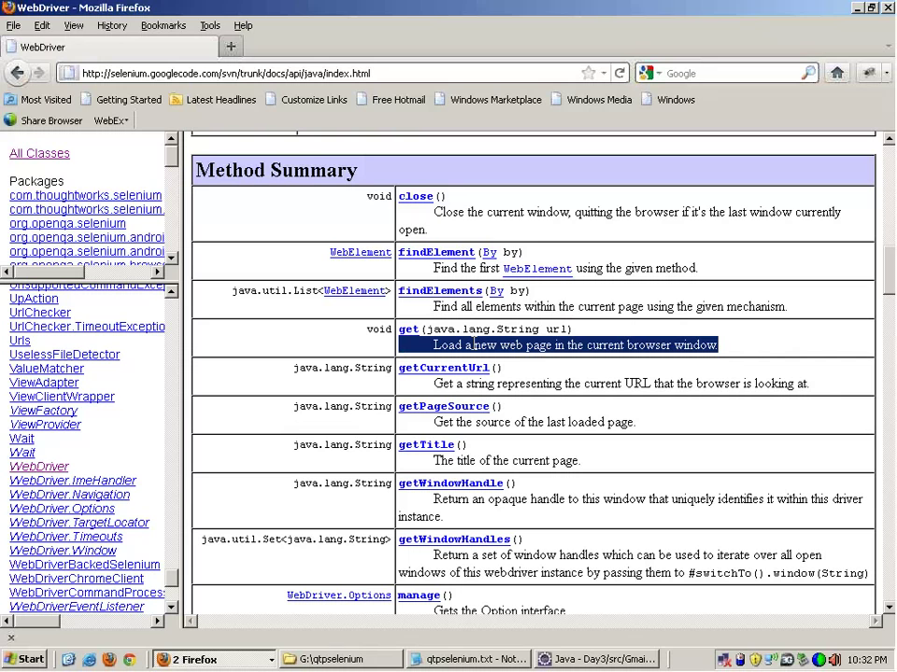

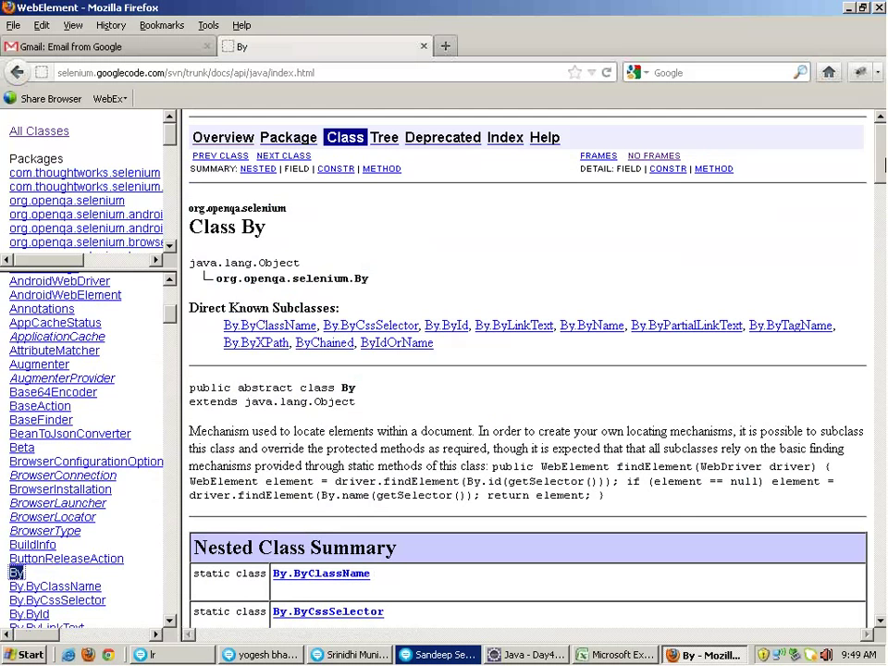

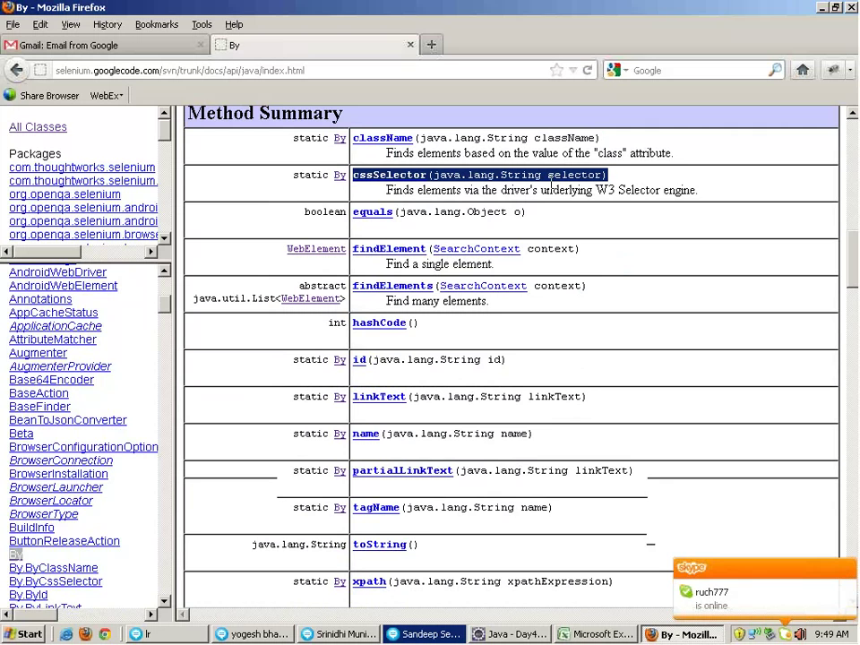

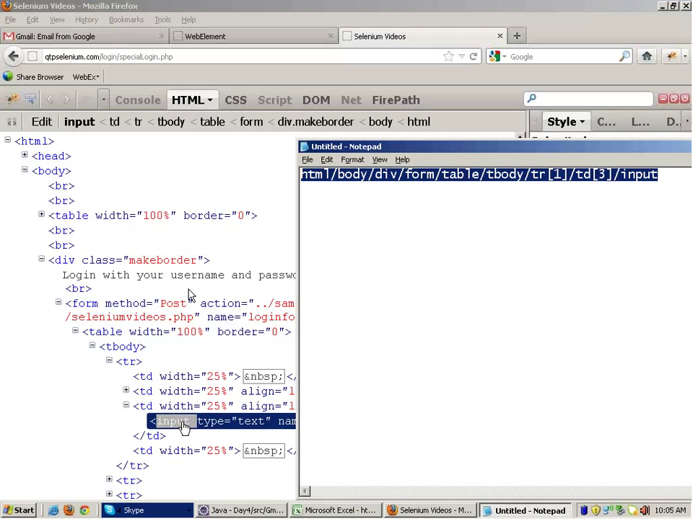

* Two type of XPath -- Absolute and relative
* Absolute xpath will start from beginning of the html like the above screenshot
* Relative xpath

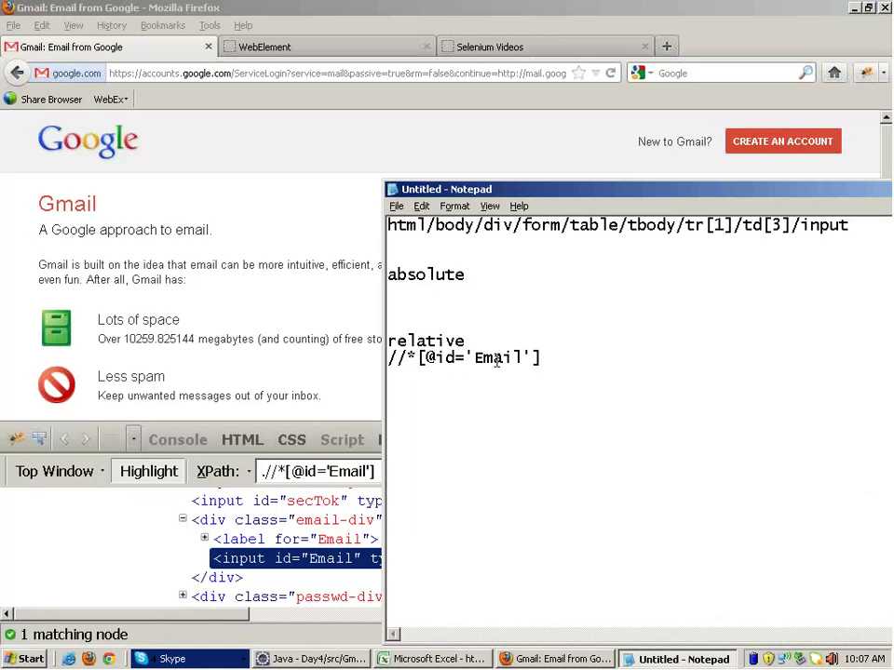

Firefox profiling

* Using this we can create multiple profile in browser.

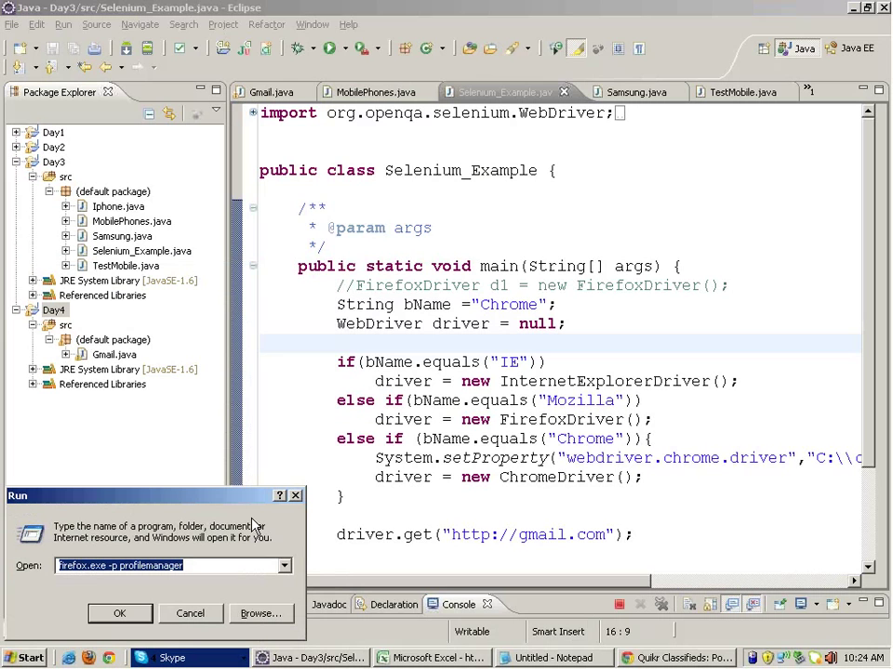

Firefox set property

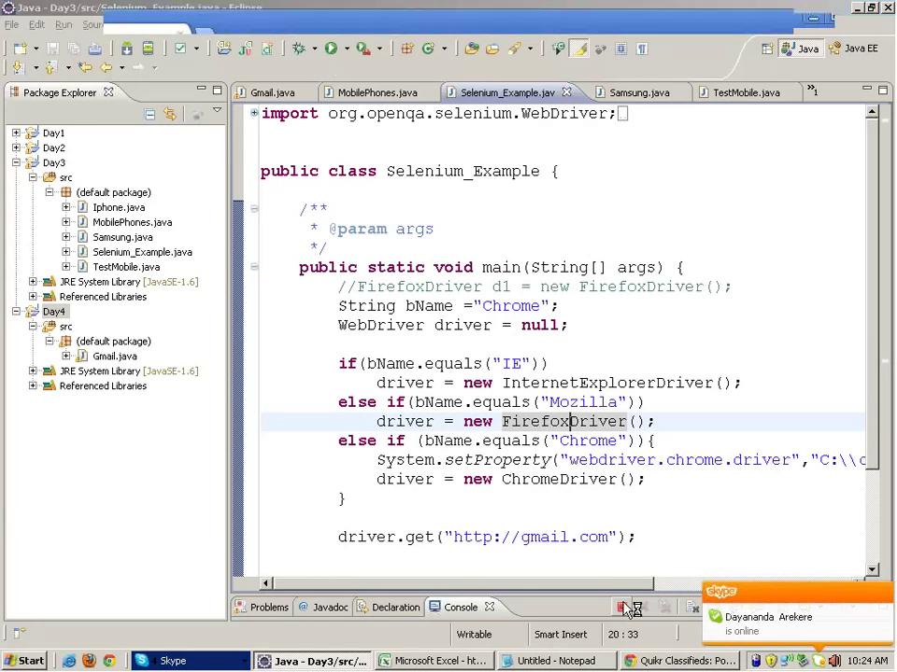

Firefox profile creation through code

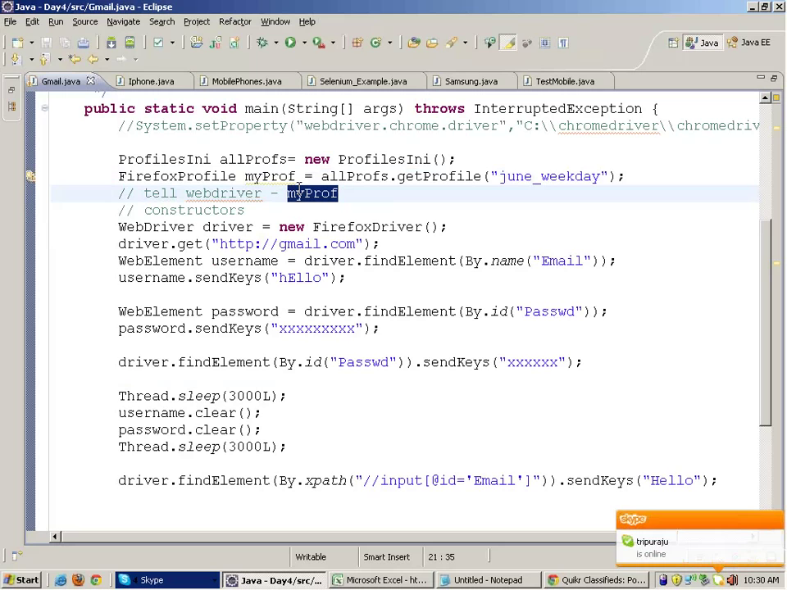

* Constructor is used for initialize object and variable value.
* Constructor name should be same as class name
* Constructor should not have return type.
* 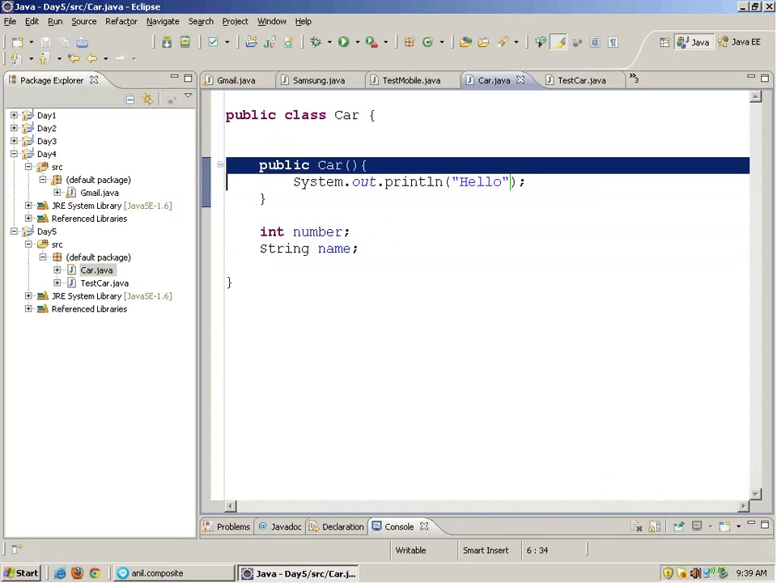
* 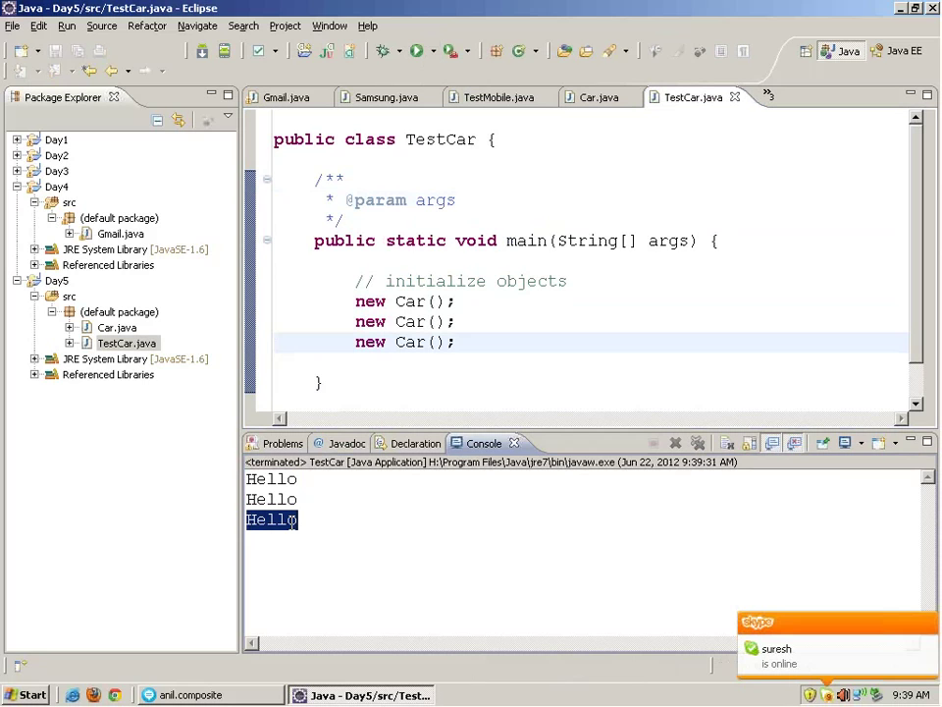
* 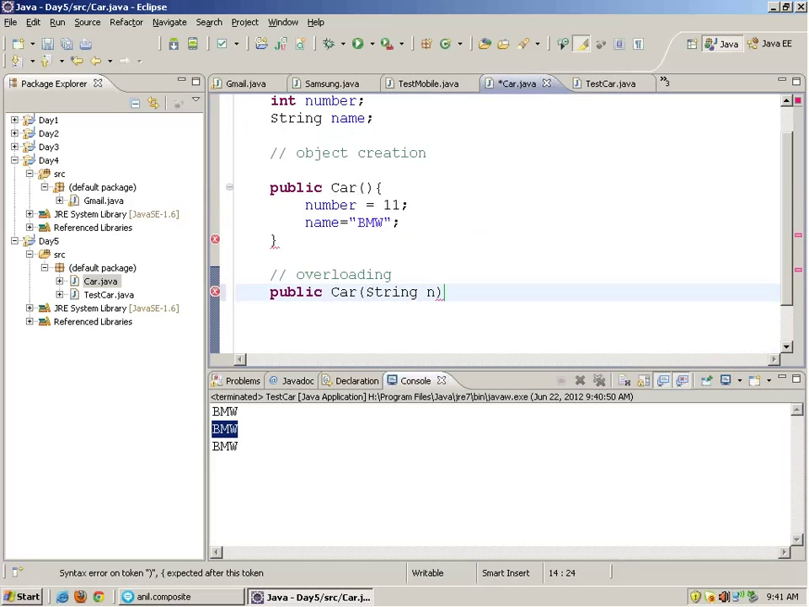
* 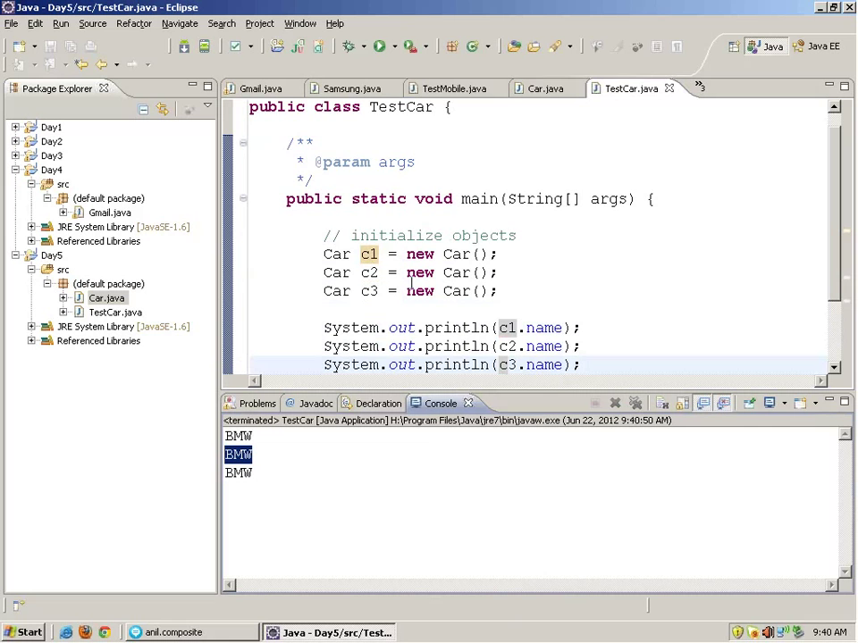
* 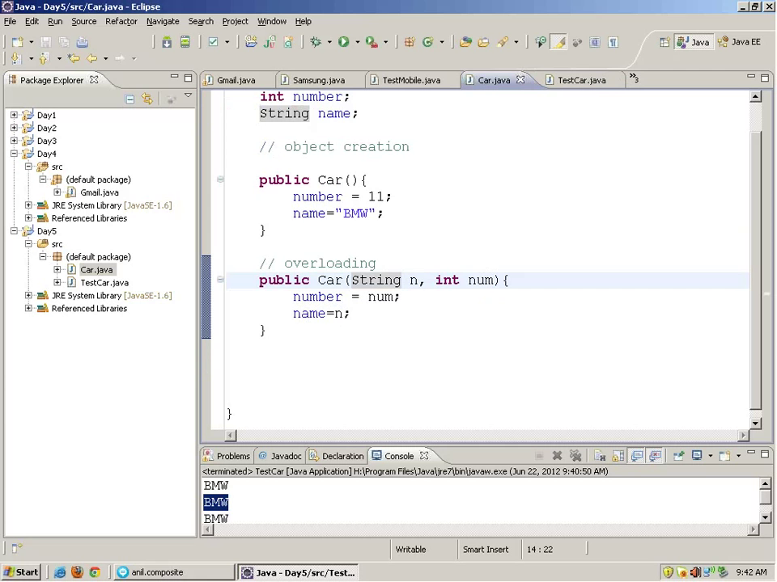
* 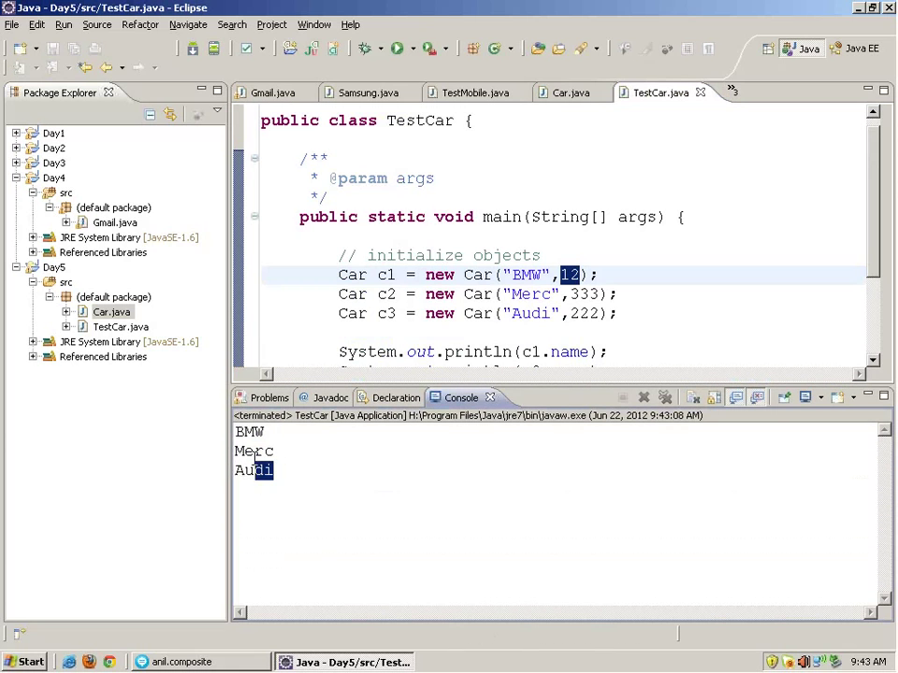
* This object
* 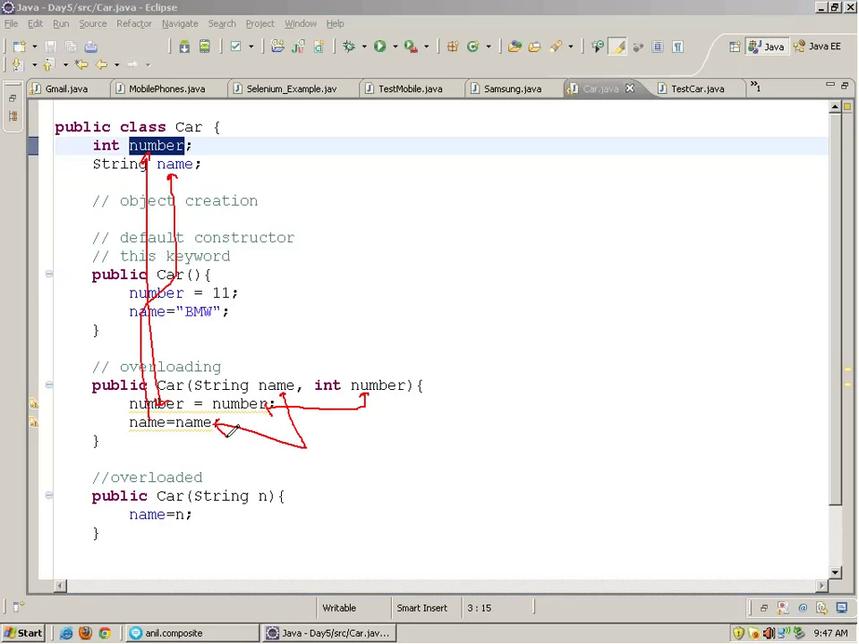
* 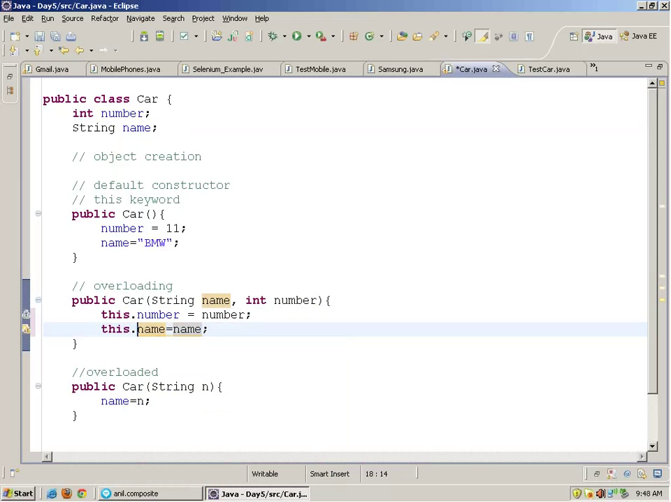
* Exception handling
* 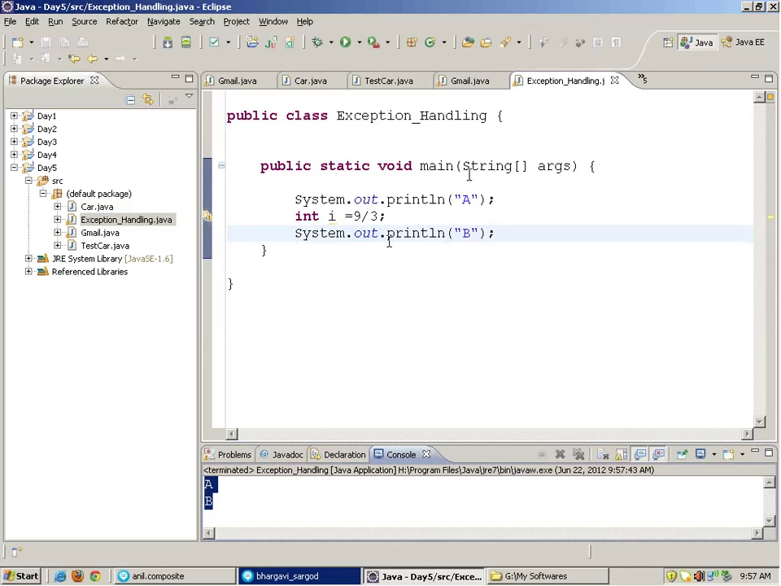
* 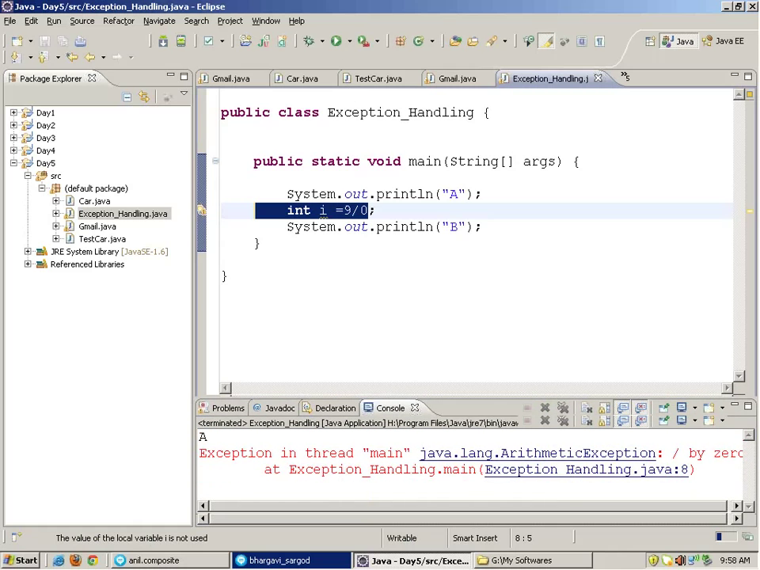
* 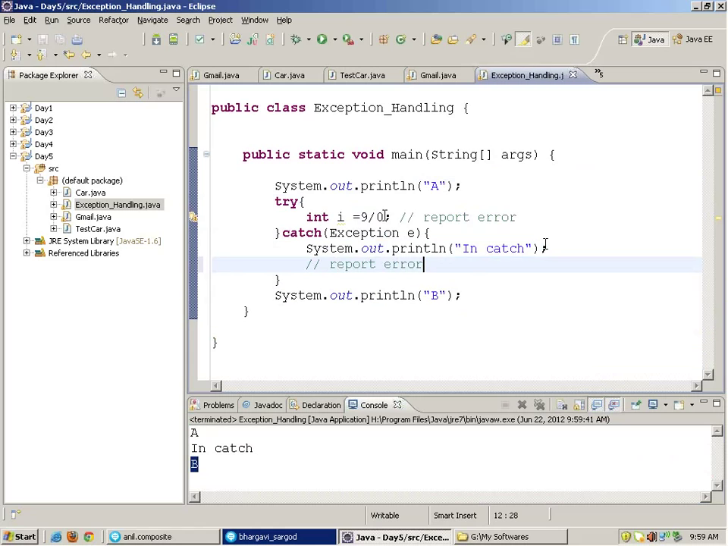
* 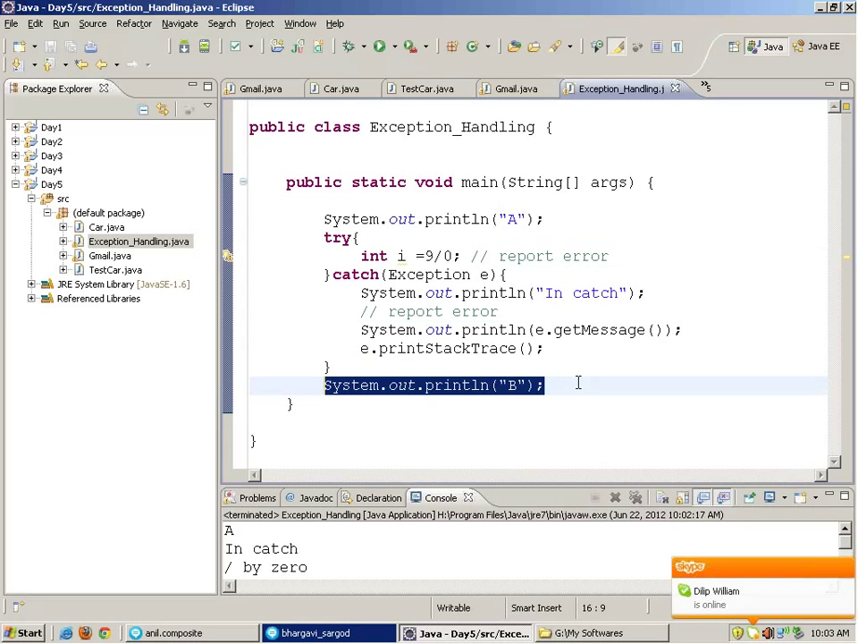
* 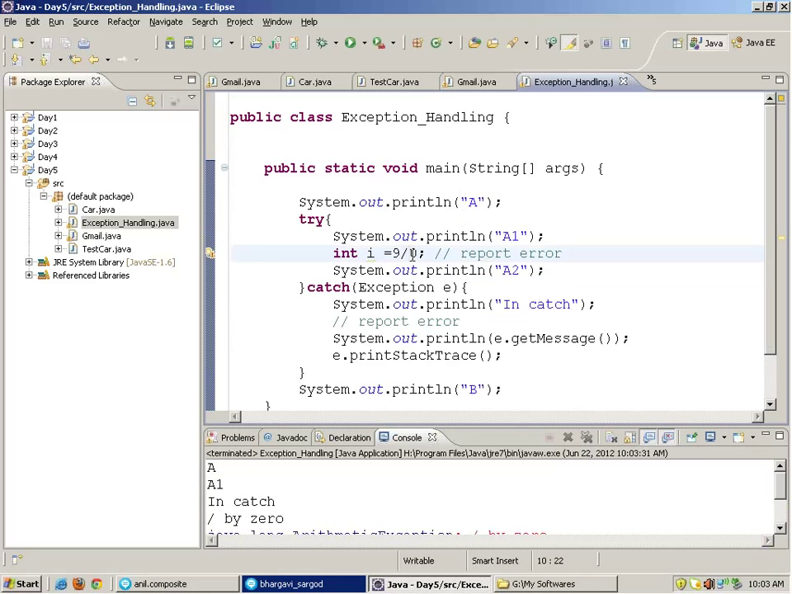
* **package** com.immco.dock1.test.core.elements;
* **import** java.util.concurrent.TimeUnit;
* **import** org.junit.After;
* **import** org.junit.Before;
* **import** org.junit.Test;
* **import** org.openqa.selenium.By;
* **import** org.openqa.selenium.WebDriver;
* **import** org.openqa.selenium.firefox.FirefoxDriver;
* **import** org.testng.annotations.BeforeTest;
* **public** **class** Testauto {
* WebDriver driver;
* @Before
* **public** **void** before()
* {
* driver=**new** FirefoxDriver();
* driver.manage().timeouts().implicitlyWait(30, TimeUnit.*SECONDS*);
* }
* @Test
* **public** **void** login() **throws** InterruptedException {
  + driver.get("http://192.168.5.129:8080/dock/Welcome.do");
* driver.findElement(By.*id*("username")).sendKeys("E000103");
* driver.findElement(By.*id*("password")).sendKeys("E000103");
* driver.findElement(By.*cssSelector*("input[type=submit]")).click();
* Thread.*sleep*(2000);
* **if**(driver.findElement(By.*linkText*("Click here")).isDisplayed())
* {
* driver.findElement(By.*linkText*("Click here")).click();
* }
* }
* @After
* **public** **void** after()
* {
* driver.quit();
* }
* }
* Automation testing or Test Automation is a process of automating the manual process to test the application/system under test. Automation testing involves use to a separate testing tool which lets you create test scripts which can be executed repeatedly and doesn’t require any manual intervention.

Selenium

1. is free and open source
2. have a large user base and helping communities
3. have cross Browser compatibility (Firefox, chrome, Internet Explorer, Safari etc.)
4. have great platform compatibility (Windows, Mac OS, Linux etc.)
5. supports multiple programming languages (Java, C#, Ruby, Python, Pearl etc.)
6. has fresh and regular repository developments
7. supports distributed testing

* [**Selenium Integrated Development Environment (IDE)**](http://www.softwaretestinghelp.com/selenium-ide-download-and-installation-selenium-tutorial-2/) – Selenium IDE is a record and playback tool. It is distributed as a Firefox Plugin.

• **Selenium Remote Control (RC)** – Selenium RC is a server that allows user to create test scripts in a desired programming language. It also allows executing test scripts within the large spectrum of browsers.

• [**Selenium WebDriver**](http://www.softwaretestinghelp.com/selenium-webdriver-selenium-tutorial-8/) – WebDriver is a different tool altogether that has various advantages over Selenium RC. WebDriver directly communicates with the web browser and uses its native compatibility to automate.

• [**Selenium Grid**](http://www.softwaretestinghelp.com/selenium-grid-selenium-tutorial-29/) – Selenium Grid is used to distribute your test execution on multiple platforms and environments concurrently.

**Selenium 3**

all the major browser vendors will ship their own WebDriver implementations

java version min 1.8

The Selenium RC APIs are only obtainable through the legacy-rc

package.

Up to version 45 (pushed to version 47), the driver used to automate Firefox was an extension included with each client

But this extension was dropped, probably due to the change of policy which now requires all the extensions to be signed by Mozilla.

Marionette is the new driver that is shipped/included with Firefox.

This driver has it's own protocol which is not directly compatible with the Selenium/WebDriver protocol.

The Gecko driver (previously named wires) is an application server implementing the Selenium/WebDriver protocol.

It translates the Selenium commands and forwards them to the Marionette driver.

For the Java client, the default behavior is to use the Gecko driver,

but it can be overridden to use the legacy extension as a driver with the webdriver.firefox.marionette property:

System.setProperty("webdriver.firefox.marionette", "false");

or with the marionette capability through FirefoxOptions :

FirefoxOptions options = new FirefoxOptions()

.setLegacy(true);

WebDriver driver = new FirefoxDriver(options);

// or with a remote server

WebDriver driver = new RemoteWebDriver(remoteUrl, options.toDesiredCapabilities());

or directly with the DesiredCapabilities:

DesiredCapabilities capa = DesiredCapabilities.firefox();

capa.setCapability("marionette", false);

WebDriver driver = new FirefoxDriver(capa);

// or with a remote server

WebDriver driver = new RemoteWebDriver(remoteUrl, capa);

And to define the location of the Gecko driver, either place the driver in a folder present in the PATH environment variable,

or define the location in the property webdriver.gecko.driver:

System.setProperty("webdriver.gecko.driver", "C:\\geckodriver.exe");

or launch a remote server with the property assigned in the command line:

java -Dwebdriver.gecko.driver="C:\\geckodriver.exe" -jar selenium-server-standalone-3.4.0.jar

Firefox 48 disabled the browser extension and introduced WebDriver. Since then GeckoDriver the Marionette-based solution,

being developed and maintained by Mozilla is for use automating Mozilla Firefox Browser.

Marionette

According to Mozilla's Official Documentation on developer.mozilla.org. Marionette is the Automation Driver.

It uses the remote protocol of Firefox which can control the UI. Marionette accepts requests and executes them in Gecko.

It also have a client. The client sends instructions to the server and the server executes the instructions within the browser.

Hence we started using Marionette:

System.setProperty("webdriver.firefox.marionette","C:\\geckodriver.exe");

WebDriver driver = new FirefoxDriver();

driver.navigate().to("https://gmail.com");

Wires –old version of gecko

There are some references to rename the executable file to ‘wires.exe’ and add it to your path. Hence the following was used:

System.setProperty("webdriver.firefox.marionette","C:\\wires.exe");

WebDriver driver = new FirefoxDriver();

driver.navigate().to("https://gmail.com");

GeckoDriver

GeckoDriver is the executable file that we need to download within our system and mention its location in our scripts/programs while executing our testcases.

GeckoDriver in turn will start the Mozilla Firefox Browser.

These excerpts have been taken out of Jim Evan's epic answer to the question What are the benefits of using Marionette FirefoxDriver

instead of the old Selenium FirefoxDriver for a Selenium tester? which provides us a detailed understanding of how GeckoDriver and Marionette came into practice.

Hence we started using geckodriver.exe:

System.setProperty("webdriver.gecko.driver", "C:\\geckodriver.exe");

WebDriver driver = new FirefoxDriver();

driver.navigate().to("https://gmail.com");

Now in current scenario you still have the option to execute your Automation through legacy Firefox 47.x browser and recent Firefox 53.x browser releases as well.

Usecase 1:

In case of using the legacy Firefox 47.x browsers you have to explicitly set "marionette" to false through DesiredCapabilities class as follows:

DesiredCapabilities dc = DesiredCapabilities.firefox();

dc.setCapability("firefox_binary", "C:\\Program Files\\Mozilla Firefox47\\firefox.exe");

dc.setCapability("marionette", false);

WebDriver driver = new FirefoxDriver(dc);

driver.navigate().to("https://gmail.com");

Usecase 2:

In case of using the legacy Firefox 47.x browsers, if you skip setting "marionette" to false or if you set "marionette" to true,

you will observe a IllegalStateException

Usecase 3:

In case of using the Firefox 53.x browsers you can choose to skip setting "marionette" to true as follows which will show the Marionette INFO logs

e.g. Marionette INFO Listening on port 11105 :

System.setProperty("webdriver.gecko.driver", "C:\\Utility\\BrowserDrivers\\geckodriver.exe");

WebDriver driver = new FirefoxDriver();

driver.navigate().to("https://gmail.com");

Usecase 4:

In case of using the Firefox 53.x browsers you can explicitly set "marionette" to true through DesiredCapabilities class

which will show the Marionette WARN logs as well e.g. WARN TLS certificate errors will be ignored for this session

System.setProperty("webdriver.gecko.driver", "C:\\Utility\\BrowserDrivers\\geckodriver.exe");

DesiredCapabilities dc = DesiredCapabilities.firefox();

dc.setCapability("marionette", true);

WebDriver driver = new FirefoxDriver(dc);

driver.navigate().to("https://gmail.com");

Usecase 5:

In case of using the Firefox 53.x browsers if you forcefully set "marionette" to false through DesiredCapabilities class you will observe a

UnreachableBrowserException.

**What are the limitations of Selenium?**

Following are the limitations of Selenium:

* Selenium supports testing of only web based applications
* Mobile applications cannot be tested using Selenium
* Captcha and Bar code readers cannot be tested using Selenium
* Reports can only be generated using third party tools like TestNG or Junit.
* As Selenium is a free tool, thus there is no ready vendor support though the user can find numerous helping communities.
* User is expected to possess prior programming language knowledge.
* Selenese is the language which is used to write test scripts in Selenium IDE.

**What are the get commands ?**

driver.get(url);

System.out.println(driver.getCurrentUrl());

System.out.println(driver.getPageSource());

System.out.println(driver.getTitle());

System.out.println(driver.getClass()); //The command is used to retrieve the Class object that represents the runtime class of this object

System.out.println(driver.getWindowHandles());

WebElement webel = driver.findElement(By.cssSelector("input[name=\"username\"]"));

System.out.println(webel.getAttribute("Name"));

System.out.println(webel.getCssValue("font-size"));

System.out.println(webel.getTagName());

System.out.println(webel.getText());

System.out.println(webel.getSize());

* **What are the different types of locators in Selenium?**
* ID
* ClassName
* Name
* TagName
* LinkText
* PartialLinkText
* Xpath
* CSS Selector
* 10down vote[favorite](https://sqa.stackexchange.com/questions/18342/how-to-handle-dynamic-changing-ids-in-xpath)
* 4
* How to Handle Dynamic Changing IDs In XPath?
* At this situation We have lots of options-
* **Option 1 :** Look for any other attribute which Is not changing every time In that div node like name, class etc. So If this div node has class attribute then we can write xpath as bellow.
* //div[@class='post-body entry-content']/div[1]/form[1]/input[1]
* **Option 2 :** We can use absolute xpath (full xpath) where you not need to give any attribute names In xpath.
* /html/body/div[3]/div[2]/div[2]/div[2]/div[2]/div[2]/div[2]/div/div[4]/div[1]/div/div/div/div[1]/div/div/div/div[1]/div[2]/div[1]/form[1]/input[1]
* **Option 3 :** We can use ‘starts-with function’. In this xpath's ID attribute, "post-body-" part remain same every time.
* //div[starts-with(@id,'post-body-')]/div[1]/form[1]/input[1]
* **Option 4 :** We can use ‘contains function’. Same way you can use contains function as bellow.
* div[contains(@id,'post-body-')]/div[1]/form[1]/input[1]
* DOM
* **What is difference between assert and verify commands?**
* **Assert:** Assert command checks whether the given condition is true or false. Let’s say we assert whether the given element is present on the web page or not. If the condition is true then the program control will execute the next test step but if the condition is false, the execution would stop and no further test would be executed.
* **Verify:** Verify command also checks whether the given condition is true or false. Irrespective of the condition being true or false, the program execution doesn’t halts i.e. any failure during verification would not stop the execution and all the test steps would be executed.
* [Xpath](http://www.softwaretestinghelp.com/using-selenium-xpath-and-other-locators-selenium-tutorial-5/) is used to locate a web element based on its XML path
* **What is the difference between “/” and “//” in Xpath?**
* **Single Slash “/” –** Single slash is used to create Xpath with absolute path i.e. the xpath would be created to start selection from the document node/start node.
* **Double Slash “//” –** Double slash is used to create Xpath with relative path i.e. the xpath would be created to start selection from anywhere within the document
* Selenium Grid can be used to execute same or different test scripts on multiple platforms and browsers concurrently so as to achieve distributed test execution, testing under different environments and saving execution time remarkable.

The different drivers available in WebDriver are:

* FirefoxDriver
* InternetExplorerDriver
* ChromeDriver
* SafariDriver
* OperaDriver
* AndroidDriver
* IPhoneDriver
* HtmlUnitDriver

**20) What are the different types of waits available in WebDriver?**

There are two [types of waits available in WebDriver](http://www.softwaretestinghelp.com/selenium-webdriver-waits-selenium-tutorial-15/):

1. Implicit Wait
2. Explicit Wait

**Implicit Wait:** Implicit waits are used to provide a default waiting time (say 30 seconds) between each consecutive test step/command across the entire test script. Thus, subsequent test step would only execute when the 30 seconds have elapsed after executing the previous test step/command.

**Explicit Wait:** Explicit waits are used to halt the execution till the time a particular condition is met or the maximum time has elapsed. Unlike Implicit waits, explicit waits are applied for a particular instance only.

Synchronization/ Waits can be achieved in many different ways :

1. **Sleep method** of Thread class

*Thread.sleep(5000*);

1. **Page Load timeout**

We can **set the amount of time to wait for a page load to complete** before throwing an error.

Example :

driver.manage().timeouts().pageLoadTimeout(20, TimeUnit.SECONDS);

1. **Script timeout**

We can set the amount of time **to wait for an asynchronous script to finish execution** before throwing any error.

Example :

driver.manage().timeouts().setScriptTimeout(20, TimeUnit.SECONDS);

Once added in the script, the WebDriver instance waits for 20 seconds for every asynchronous script to get executed on the web page before throwing an exception.

1. **Implicit Wait**

Implicit wait is a mechanism, which is used **to notify WebDriver instance to wait for specific time**, if **any element is readily not available** on the webpage.

driver.manage().timeouts().implicitlyWait(10, TimeUnit.SECONDS);

The above line once added at the beginning of the automation script, the WebDriver will wait for 10 SECONDS for any element on the web page to be loaded before throwing any exception.

Once set, the timing will be set **for the life of the WebDriver instance** until and unless it is changed again. Meaning, using implicit wait command, we can say the **WebDriver instance to wait for specified amount time** before throwing NoSuchElementException, if it does not find any element on the web page immediately.

The synchronization mechanism is **not associated with any particular web element**, so it will be **applicable for all the elements that our script interacts with**, it is not highly appreciated.

1. **Explicit Wait**

Explicit wait is a technique used to advise the **WebDriver instance to stand by** the **execution** till the time the **certain condition is met** or **the maximum wait time is elapsed**.

*WebElement element = driver.findElement(By.linkText(“Home”));*  
*WebDriverWait wait = new WebDriverWait(driver, 20);*

*wait.until(ExpectedConditions.visibilityOf(element));*

The above line sets maximum time the WebDriver instance will wait for the condition to become true.

WebDriverWait wait=**new** WebDriverWait(driver,20);

wait.until(ExpectedConditions.*presenceOfElementLocated*(By.*cssSelector*("input[name=\"username\"]")))// this directly use locators

wait.until(ExpectedConditions.*elementToBeClickable*(driver.findElement(By.*cssSelector*("input#sign_up_form_password"))));// used web element locator/web element

We can make the WebDriver instance wait until –

* an element is visible on the web page - visibilityOfElementLocated(locator)
* an alert is visible on the web page - alertIsPresent() //no parameters
* a frame is displayed on the web page – frameToBeAvailableAndSwitchToIt(bylocator/int frame locator/string frame locator/webelementframe locator)
* multiple elements are visible on the web page
* and many more…..

**How can you find if an element in displayed on the screen?**

WebDriver facilitates the user with the following methods to check the visibility of the web elements. These web elements can be buttons, drop boxes, checkboxes, radio buttons, labels etc.

1. isDisplayed()
2. isSelected()
3. isEnabled()

**How can we get a text of a web element?**

**Syntax:**  
String Text = driver.findElement(By.id(“Text”)).getText();

**How to select value in a dropdown?**

**selectByValue:**  
Select selectByValue = **new** Select(driver.findElement(By.id(“SelectID_One”)));  
selectByValue.selectByValue(“greenvalue”);

**selectByVisibleText:**  
Select selectByVisibleText = **new** Select (driver.findElement(By.id(“SelectID_Two”)));  
selectByVisibleText.selectByVisibleText(“Lime”);

**selectByIndex:**  
Select selectByIndex = **new** Select(driver.findElement(By.id(“SelectID_Three”)));  
selectByIndex.selectByIndex(2);

**What are the different types of navigation commands?**

Following are the [navigation commands](http://www.softwaretestinghelp.com/selenium-webdriver-waits-selenium-tutorial-15/):  
**navigate().back()** – The above command requires no parameters and takes back the user to the previous webpage in the web browser’s history.

**Sample code:**  
driver.navigate().back();

**navigate().forward()** – This command lets the user to navigate to the next web page with reference to the browser’s history.

**Sample code:**  
driver.navigate().forward();

**navigate().refresh()** – This command lets the user to refresh the current web page there by reloading all the web elements.

**Sample code:**  
driver.navigate().refresh();

**navigate().to()** – This command lets the user to launch a new web browser window and navigate to the specified URL.

**Sample code:**  
driver.navigate().to(“https://google.com”)

difference between driver.get() and driver.navigate.to()?

navigate.to() will maintain history where as get() is not.

Get :

1. Waits till complete page loads.

2. can not move forward & backward in the browser.

Navigate :

1. Will not wait until the page loads, you can feel this experience only if page takes time to load, like more number of images or ajax calls etc......  
2. can move forward & backward in the browser.

**When do we use findElement() and findElements()?**

**findElement():** findElement() is used to find the first element in the current web page matching to the specified locator value. Take a note that only first matching element would be fetched.

**Syntax:**

WebElement element = driver.findElements(By.xpath(“//div[@id=’example’]//ul//li”));  
**findElements():** findElements() is used to find all the elements in the current web page matching to the specified locator value. Take a note that all the matching elements would be fetched and stored in the list of WebElements.

**Syntax:**  
List <WebElement> elementList = driver.findElements(By.xpath(“//div[@id=’example’]//ul//li”));

**What is the difference between driver.close() and driver.quit command?**

**close()**: WebDriver’s close() method closes the web browser window that the user is currently working on or we can also say the window that is being currently accessed by the WebDriver. The command neither requires any parameter nor does is return any value.

**quit()**: Unlike close() method, quit() method closes down all the windows that the program has opened. Same as close() method, the command neither requires any parameter nor does is return any value.

**How to assert title of the web page?**

//verify the title of the web page  
assertTrue(“The title of the window is incorrect.”,driver.getTitle().equals(“Title of the page”));

# Execute JavaScript based code

In case, these locators do not work you can use JavaScriptExecutor. You can use JavaScriptExecutor to perform an desired operation on a web element.

JavaScriptExecutor is an Interface that helps to execute [JavaScript](https://www.guru99.com/interactive-javascript-tutorials.html) through Selenium Webdriver.

JavaScriptExecutor provides two methods

"executescript"

"executeAsyncScript"

1. **executeAsyncScript**

With Asynchronous script, your page renders more quickly. Instead of forcing users to wait for a script to download before the page renders. This function will execute an asynchronous piece of JavaScript in the context of the currently selected frame or window in Selenium. The JS so executed is single-threaded with a various callback function which runs synchronously.

**Syntax:**

* JavascriptExecutor js = (JavascriptExecutor) driver;
* js.executeAsyncScript(Script,Arguments);

eg: //Call executeAsyncScript() method to wait for 5 seconds

js.executeAsyncScript("window.setTimeout(arguments[arguments.length - 1], 5000);");

***Script –*** The JavaScript to execute ***Arguments –***The arguments to the script(Optional). May be empty. ***Returns –***One of Boolean, Long, String, List, WebElement, or null.

1. **executeScript**

This method executes JavaScript in the context of the currently selected frame or window in Selenium. The script used in this method runs in the body of an anonymous function (a function without a name). We can also pass complicated arguments to it.

The script can return values. Data types returned are

* Boolean
* Long
* String
* List
* WebElement.

**Syntax:**

* JavascriptExecutor js = (JavascriptExecutor) driver;
* js.executeScript(Script,Arguments);

eg:

//Perform Click on LOGIN button using JavascriptExecutor

js.executeScript("arguments[0].click();", button);

//To generate Alert window using JavascriptExecutor. Display the alert message

js.executeScript("alert('Welcome to Guru99');");

//Fetching the Domain Name of the site. Tostring() change object to name.

String DomainName = js.executeScript("return document.domain;").toString();

System.out.println("Domain name of the site = "+DomainName);

//Fetching the URL of the site. Tostring() change object to name

String url = js.executeScript("return document.URL;").toString();

System.out.println("URL of the site = "+url);

//Method document.title fetch the Title name of the site. Tostring() change object to name

String TitleName =

js.executeScript("return document.title;").toString();

System.out.println("Title of the page = "+TitleName);

//Navigate to new Page i.e to generate access page. (launch new url)

js.executeScript("window.location = 'http://demo.guru99.com/'");

//Vertical scroll down by 600 pixels

js.executeScript("window.scrollBy(0,600)");

To type Text in Selenium WebDriver without using sendKeys() method

js.executeScript("document.getElementById('some id').value='someValue';");

To click a Button in Selenium WebDriver using JavaScript

js.executeScript("document.getElementById('enter your element id').click();");

//or

js.executeScript("arguments[0].click();", loginButton);

To handle Checkbox

js.executeScript("document.getElementById('enter element id').checked=false;");

To refresh browser window using Javascript

js.executeScript("history.go(0)");

To get innertext of the entire webpage in Selenium

String sText = js.executeScript("return document.documentElement.innerText;").toString();

System.out.println(sText);

To click on a SubMenu which is only visible on mouse hover on Menu

js.executeScript("$('ul.menus.menu-secondary.sf-js-enabled.sub-menu li').hover()");

js.executeScript("$('ul.menus.menu-secondary.sf-js-enabled.sub-menu li')

To find hidden element in selenium using JavaScriptExecutor

js.executeScript("arguments[0].click();", element);

Actions Class

*************************

|  |  |
| --- | --- |
| [Actions](https://seleniumhq.github.io/selenium/docs/api/java/org/openqa/selenium/interactions/Actions.html) | [click](https://seleniumhq.github.io/selenium/docs/api/java/org/openqa/selenium/interactions/Actions.html#click--)()  Clicks at the current mouse location. |
| [Actions](https://seleniumhq.github.io/selenium/docs/api/java/org/openqa/selenium/interactions/Actions.html) | [click](https://seleniumhq.github.io/selenium/docs/api/java/org/openqa/selenium/interactions/Actions.html#click-org.openqa.selenium.WebElement-)([WebElement](https://seleniumhq.github.io/selenium/docs/api/java/org/openqa/selenium/WebElement.html) target)  Clicks in the middle of the given element. |
| [Actions](https://seleniumhq.github.io/selenium/docs/api/java/org/openqa/selenium/interactions/Actions.html) | [clickAndHold](https://seleniumhq.github.io/selenium/docs/api/java/org/openqa/selenium/interactions/Actions.html#clickAndHold--)()  Clicks (without releasing) at the current mouse location. |
| [Actions](https://seleniumhq.github.io/selenium/docs/api/java/org/openqa/selenium/interactions/Actions.html) | [clickAndHold](https://seleniumhq.github.io/selenium/docs/api/java/org/openqa/selenium/interactions/Actions.html#clickAndHold-org.openqa.selenium.WebElement-)([WebElement](https://seleniumhq.github.io/selenium/docs/api/java/org/openqa/selenium/WebElement.html) target)  Clicks (without releasing) in the middle of the given element. |
| [Actions](https://seleniumhq.github.io/selenium/docs/api/java/org/openqa/selenium/interactions/Actions.html) | [contextClick](https://seleniumhq.github.io/selenium/docs/api/java/org/openqa/selenium/interactions/Actions.html#contextClick--)()  Performs a context-click at the current mouse location. |
| [Actions](https://seleniumhq.github.io/selenium/docs/api/java/org/openqa/selenium/interactions/Actions.html) | [contextClick](https://seleniumhq.github.io/selenium/docs/api/java/org/openqa/selenium/interactions/Actions.html#contextClick-org.openqa.selenium.WebElement-)([WebElement](https://seleniumhq.github.io/selenium/docs/api/java/org/openqa/selenium/WebElement.html) target)  Performs a context-click at middle of the given element. |
| [Actions](https://seleniumhq.github.io/selenium/docs/api/java/org/openqa/selenium/interactions/Actions.html) | [doubleClick](https://seleniumhq.github.io/selenium/docs/api/java/org/openqa/selenium/interactions/Actions.html#doubleClick--)()  Performs a double-click at the current mouse location. |
| [Actions](https://seleniumhq.github.io/selenium/docs/api/java/org/openqa/selenium/interactions/Actions.html) | [doubleClick](https://seleniumhq.github.io/selenium/docs/api/java/org/openqa/selenium/interactions/Actions.html#doubleClick-org.openqa.selenium.WebElement-)([WebElement](https://seleniumhq.github.io/selenium/docs/api/java/org/openqa/selenium/WebElement.html) target)  Performs a double-click at middle of the given element. |
| [Actions](https://seleniumhq.github.io/selenium/docs/api/java/org/openqa/selenium/interactions/Actions.html) | [dragAndDrop](https://seleniumhq.github.io/selenium/docs/api/java/org/openqa/selenium/interactions/Actions.html#dragAndDrop-org.openqa.selenium.WebElement-org.openqa.selenium.WebElement-)([WebElement](https://seleniumhq.github.io/selenium/docs/api/java/org/openqa/selenium/WebElement.html) source, [WebElement](https://seleniumhq.github.io/selenium/docs/api/java/org/openqa/selenium/WebElement.html) target)  A convenience method that performs click-and-hold at the location of the source element, moves to the location of the target element, then releases the mouse. |
| [Actions](https://seleniumhq.github.io/selenium/docs/api/java/org/openqa/selenium/interactions/Actions.html) | [dragAndDropBy](https://seleniumhq.github.io/selenium/docs/api/java/org/openqa/selenium/interactions/Actions.html#dragAndDropBy-org.openqa.selenium.WebElement-int-int-)([WebElement](https://seleniumhq.github.io/selenium/docs/api/java/org/openqa/selenium/WebElement.html) source, int xOffset, int yOffset)  A convenience method that performs click-and-hold at the location of the source element, moves by a given offset, then releases the mouse. |
| [Actions](https://seleniumhq.github.io/selenium/docs/api/java/org/openqa/selenium/interactions/Actions.html) | [keyDown](https://seleniumhq.github.io/selenium/docs/api/java/org/openqa/selenium/interactions/Actions.html#keyDown-java.lang.CharSequence-)(java.lang.CharSequence key)  Performs a modifier key press. |
| [Actions](https://seleniumhq.github.io/selenium/docs/api/java/org/openqa/selenium/interactions/Actions.html) | [keyDown](https://seleniumhq.github.io/selenium/docs/api/java/org/openqa/selenium/interactions/Actions.html#keyDown-org.openqa.selenium.WebElement-java.lang.CharSequence-)([WebElement](https://seleniumhq.github.io/selenium/docs/api/java/org/openqa/selenium/WebElement.html) target, java.lang.CharSequence key)  Performs a modifier key press after focusing on an element. |
| [Actions](https://seleniumhq.github.io/selenium/docs/api/java/org/openqa/selenium/interactions/Actions.html) | [keyUp](https://seleniumhq.github.io/selenium/docs/api/java/org/openqa/selenium/interactions/Actions.html#keyUp-java.lang.CharSequence-)(java.lang.CharSequence key)  Performs a modifier key release. |
| [Actions](https://seleniumhq.github.io/selenium/docs/api/java/org/openqa/selenium/interactions/Actions.html) | [keyUp](https://seleniumhq.github.io/selenium/docs/api/java/org/openqa/selenium/interactions/Actions.html#keyUp-org.openqa.selenium.WebElement-java.lang.CharSequence-)([WebElement](https://seleniumhq.github.io/selenium/docs/api/java/org/openqa/selenium/WebElement.html) target, java.lang.CharSequence key)  Performs a modifier key release after focusing on an element. |

**How to use frames?**

**a) frame(index)**  
*driver.switchTo().frame(0);*

**b) frame(Name of Frame)**  
*driver.switchTo().frame(“name of the frame”);*

**c) frame(WebElement element)**  
Select Parent Window  
*driver.switchTo().defaultContent();*

The above command brings the user back to the original window i.e. out of both the iframes.

It does have difference to an extent. Suppose you have a page having frame 'three' inside a frame 'two' inside another frame 'one', considering that you are on the frame 'three' which is inner most...

driver.switchTo().parentFrame(); - This will shift focus back to frame 'two'. driver.switchTo().defaultContent(); - This will shift focus back to main (default) content in which frame 'one' lies.

**What is Junit?**

[Junit](http://www.softwaretestinghelp.com/selenium-junit-framework-selenium-tutorial-11/) is a unit testing framework introduced by Apache. Junit is based on Java.

**What are Junit annotations?**

Following are the Junit Annotations:

* **@Test:** Annotation lets the system know that the method annotated as @Test is a test method. There can be multiple test methods in a single test script.
* **@Before:** Method annotated as @Before lets the system know that this method shall be executed every time before each of the test method.
* **@After:** Method annotated as @After lets the system know that this method shall be executed every time after each of the test method.
* **@BeforeClass:** Method annotated as @BeforeClass lets the system know that this method shall be executed once before any of the test method.
* **@AfterClass:** Method annotated as @AfterClass lets the system know that this method shall be executed once after any of the test method.
* **@Ignore:** Method annotated as @Ignore lets the system know that this method shall not be executed.

TestNG Assert

Like wise there are many Assertions provided by the TestNG. The below are the few which are used commonly.

*assertEqual(String actual,String expected)*:- It takes two string arguments and checks whether both are equal, if not it will fail the test.

*assertEqual(String actual,String expected, String message)* :- It takes three string arguments and checks whether both are equal, if not it will fail the test and throws the message which we provide.

assertEquals(boolean actual,boolean expected) :- It takes two boolean arguments and checks whether both are equal, if not it will fail the test.

*assertEquals(java.util.Collection actual, java.util.Collection expected, java.lang.String message)*:- Takes two collection objects and verifies both collections contain the same elements and with the same order. if not it will fail the test with the given message.

*Assert.assertTrue(condition)* :- It takes one boolean arguments and checks that a condition is true, If it isn't, an AssertionError is thrown.

*Assert.assertTrue(condition, message)*:- It takes one boolean argument and String message. It Asserts that a condition is true. If it isn't, an AssertionError, with the given message, is thrown.

*Assert.assertFalse(condition)*:- It takes one boolean arguments and checks that a condition is false, If it isn't, an AssertionError is thrown.

*Assert.assertFalse(condition, message)*:- It takes one boolean argument and String message. It Asserts that a condition is false. If it isn't, an AssertionError, with the given message, is thrown.

Skip in testng

*@Test(enabled=false)* annotation is used to skip a test case if it is not ready to test

throw new SkipException("message");

***CONDITIONAL Skip***, i.e..

if(!DataAvailable)

throw new SkipException("Skipping this exception");

**What is TestNG and how is it better than Junit?**

TestNG with WebDriver provides an efficient and effective test result format that can in turn be shared with the stake holders to have a glimpse on the product’s/application’s health thereby eliminating the drawback of WebDriver’s incapability to generate test reports. TestNG has an inbuilt exception handling mechanism which lets the program to run without terminating unexpectedly.

There are various advantages that make TestNG superior to JUnit. Some of them are:

* Added advance and easy annotations
* Execution patterns can set
* Concurrent execution of test scripts
* Test case dependencies can be set

**How to set test case priority in TestNG?**

* **Setting Priority in TestNG**
* **Code Snippet**

|  |  |
| --- | --- |
| 1 | package TestNG; |
| 2 | import org.testng.annotations.*; | |

|  |  |  |
| --- | --- | --- |
| 3 | public class SettingPriority { | |
| 4 | @Test(priority=0) |

|  |  |  |
| --- | --- | --- |
| 5 | public void method1() { | |
| 6 | } |

|  |  |
| --- | --- |
| 7 | @Test(priority=1) |
| 8 | public void method2() { | |

|  |  |  |
| --- | --- | --- |
| 9 | } | |
| 10 | | @Test(priority=2) | |

|  |  |  |
| --- | --- | --- |
| 11 | public void method3() { | |
| 12 | } |

|  |  |
| --- | --- |
| 13 | } |

**What is the difference between Selenium and QTP?**

| **Feature** | **Selenium** | **Quick Test Professional (QTP)** |
| --- | --- | --- |
| Browser Compatibility | Selenium supports almost all the popular browsers like Firefox, Chrome, Safari, Internet Explorer, Opera etc | QTP supports Internet Explorer, Firefox and Chrome. QTP only supports Windows Operating System |
| Distribution | Selenium is distributed as an open source tool and is freely available | QTP is distributed as a licensed tool and is commercialized |
| Application under Test | Selenium supports testing of only web based applications | QTP supports testing of both the web based application and windows based application |
| Object Repository | Object Repository needs to be created as a separate entity | QTP automatically creates and maintains Object Repository |
| Language Support | Selenium supports multiple programming languages like Java, C#, Ruby, Python, Perl etc | QTP supports only VB Script |
| Vendor Support | As Selenium is a free tool, user would not get the vendor’s support in troubleshooting issues | Users can easily get the vendor’s support in case of any issue |

* **Question 6:** Which web driver implementation is fastest?  
  **Answer:** HTMLUnitDriver. Simple reason is HTMLUnitDriver does not execute tests on browser but plain http request – response which is far quick than launching a browser and executing tests. But then you may like to execute tests on a real browser than something running behind the scenes
* driver.findElement(By.id("HTMLid"));
* driver.findElement(By.name("HTMLname"));
* driver.findElement(By.cssSelector("cssLocator"));
* driver.findElement(By. className ("CalssName”));
* driver.findElement(By. linkText ("LinkeText”));
* driver.findElement(By. partialLinkText ("PartialLink”));
* driver.findElement(By. tagName ("TanName”));
* driver.findElement(By.xpath("XPathLocator))
* How do I submit a form using Selenium?  
  **Answer:**
* WebElement el  =  driver.findElement(By.id("ElementID"));
* el.submit();
* How to count total number of rows of a table using Selenium 2.0?
* **Answer:**
* List {WebElement} rows = driver.findElements(By.className("//table[@id='tableID']/tr"));
* int totalRow = rows.size();
* How to capture page title using Selenium 2.0?
* **Answer:**
* String title =  driver.getTitle()
* How to store page source using Selenium 2.0?
* **Answer:**
* String pagesource = driver.getPageSource()
* How to store current url using selenium 2.0?
* **Answer:**
* String currentURL  = driver.getCurrentUrl()
* How to assert text assert text of webpage using selenium 2.0?
* **Answer:**
* WebElement el  =  driver.findElement(By.id("ElementID"));
* //get test from element and stored in text variable
* String text = el.getText();
* //assert text from expected
* Assert.assertEquals("Element Text", text);
* How to double click on element using selenium 2.0?
* **Answer:**
* WebElement el  =  driver.findElement(By.id("ElementID"));
* Actions builder = new Actions(driver);
* builder.doubleClick(el).build().perform();
* How to perform drag and drop in selenium 2.0?
* **Answer:**
* WebElement source  =  driver.findElement(By.id("Source ElementID"));
* WebElement destination  =  driver.findElement(By.id("Taget ElementID"));
* Actions builder = new Actions(driver);
* builder.dragAndDrop(source, destination ).perform();
* How to maximize window using selenium 2.0?
* **Answer:**
* driver.manage().window().maximize();

1. **How to retrieve css properties of an element?**
2. The values of the css properties can be retrieved using a get() method:
3. **Syntax:**  
   driver.findElement(By.id(“id“)).getCssValue(“name of css attribute”);  
   driver.findElement(By.id(“id“)).getCssValue(“font-size”);

**What is Object Repository? How can we create Object Repository in Selenium?**

Object Repository is a term used to refer to the collection of web elements belonging to Application Under Test (AUT) along with their locator values. Thus, whenever the element is required within the script, the locator value can be populated from the Object Repository. Object Repository is used to store locators in a centralized location instead of hard coding them within the scripts.

1. In Selenium, objects can be stored in an excel sheet which can be populated inside the script whenever required.

How to capture screen shot in Webdriver?

1. **Answer:**
2. File file= ((TakesScreenshot)driver).getScreenshotAs(OutputType.FILE);
3. FileUtils.copyFile(file, new File("c:\\name.png"));
4. How do I clear content of a text box in Selenium 2.0?
5. Answer:
6. WebElement el  =  driver.findElement(By.id("ElementID"));
7. el.clear();

**What is selenium server vs selenium hub?**

Selenium server is a standalone application for using a single server as a test node. Selenium hub acts as a proxy in front of one or more Selenium node instances. A hub + node(s) is called a Selenium grid. Running Selenium server is similar to creating a Selenium grid from a hub and a single node on the same host.

**How do you connect to Data base from selenium?**

Connection con = DriverManager.getConnection(url, "userID", "password");

**catch (Exception e) {**

**e.printStackTrace();**

**}**

**Can we run group of test cases using TestNG?**

**Answer:**

Test cases in group using TestNG will be executed with the below options.

If you want to execute the test cases based on one of the group like regression test or smoke test-

@Test(groups = {“regressiontest”, “smoketest”})

* Static testing is a system of White Box testing where developers verify or check code to find fault. This type of testing is completed without executing the applications that are currently developed. Dynamic Testing is completed by walking the real application with valid entries to verify the expected results. Examples of methodologies for dynamic testing are unit testing, integration testing, system testing & acceptance testing.
* Under**Static Testing** code is not executed. Rather it manually checks the code, requirement documents, and design documents to find errors. Hence, the name "static".
* Main objective of this testing is to improve the quality of software products by finding errors in early stages of the development cycle. This testing is also called as Non-execution technique or **verification testing**.
* Static testing involves manual or automated **reviews** of the documents. This review, is  done during initial phase of testing to catch defect early in STLC. It examines work documents and provides review comments

**Inspection** by moderator  **Walkthrough** by author **Technical reviews Informal reviews**:

* Under**Dynamic Testing** code is executed. It checks for functional behavior of software system , memory/cpu usage and overall performance of the system. Hence the name "Dynamic"
* **Unit Testing:** Testing of individual modules by developers.. The source code is tested in it.
* **Integration Testing:**Testing the interface between different modules then they are joined..
* **System Testing:**Testing performed on the system as a whole.
* **Acceptance Testing:** Testing done from user point of view at user’s end.

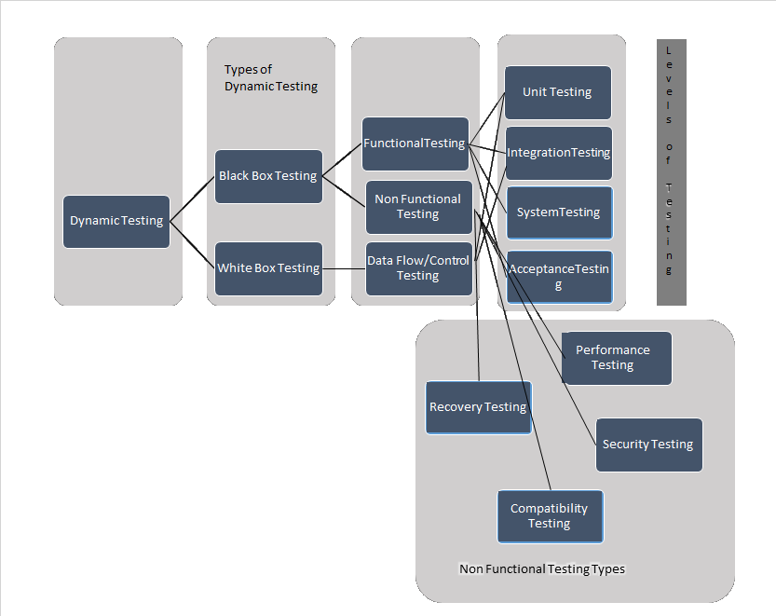

* Regression testing is the process of testing changes to computer programs to make sure that the older programming still works with the new changes. Regression testing is a normal part of the program development process and, in larger companies, is done by code testing specialists. Test department coders develop code test scenarios and exercises that will test new units of code after they have been written. These test cases form what becomes the *test bucket*. Before a new version of a software product is released, the old test cases are run against the new version to make sure that all the old capabilities still work. The reason they might not work is because changing or adding new code to a program can easily introduce errors into code that is not intended to be changed.
* **what is Smoke Testing?**
* Smoke Testing is performed after software build to **ascertain that the critical functionalities of the program is working fine**.It is executed **"before"** any detailed functional or regression tests are executed on the software build.The **purpose is to reject a badly broken application**, so that the QA team does not waste time installing and testing the software application.
* In Smoke Testing, the **test cases chosen cover the most important functionality** or component of the system. The objective is not to perform exhaustive testing, but to verify that the critical functionalities of the system is working fine.  
  For Example a typical smoke test would be - Verify that the application launches successfully, Check that the GUI is responsive ... etc.

## what is Sanity Testing?

After receiving a **software build, with minor changes in code, or functionality, Sanity testing is performed to ascertain that the bugs have been fixed and no further issues are introduced due to these changes**.The goal is to determine that the proposed functionality works roughly as expected. **If sanity test fails, the build is rejected to save the time and costs involved in a more rigorous testing**.

## What is Exhaustive Testing?

Exhaustive testing is a test approach in which all possible data combinations are used for testing. Exploratory testing includes implicit data combinations present in the state of the software/data at the start of testing.

## Example:

Consider an application in which a password field that accepts 3 characters, with no consecutive repeating entries. Hence, there are 26 * 26 * 26 input permutations for alphabets only. Including special characters and standard characters, there are much more combinations. So, there are 256 * 256 * 256 input combinations.

## What is a Test Plan?

Test planning, the most important activity to ensure that there is initially a list of tasks and milestones in a baseline plan to track the progress of the project. It also defines the size of the test effort.

It is the main document often called as master test plan or a project test plan and usually developed during the early phase of the project.

**test plan**: A document describing the scope, approach, resources and schedule of intended test activities. It identifies amongst others test items, the features to be tested, the testing tasks, who will do each task, degree of tester independence, the test environment, the test design techniques and entry and exit criteria to be used, and the rationale for their choice,and any risks requiring contingency planning. It is a record of the test planning process.

# Software Testing Life Cycle STLC

**Software Testing Life Cycle (STLC)** isthe testing process which is executed in systematic and planned manner. In STLC process,different activities are carried  out to improve the quality of the product. Let’s quickly see what all stages are involved in typical Software Testing Life Cycle (STLC).

Following steps are involved in Software Testing Life Cycle (STLC). Each step is have its own Entry Criteria and deliverable.

* Requirement Analysis
* Test Planning
* Test Case Development
* Environment Setup
* Test Execution
* Test Cycle Closure

What is Requirement traceability Matrix (RTM)?

Requirements tracing, a process of documenting the links between the requirements and the work products developed to implement and verify those requirements. The RTM captures all requirements and their traceability in a single document delivered at the conclusion of the life cycle.

RTM - WorkFlow:

The Matrix is created at the very beginning of a project as it forms the basis of the project's scope and deliverables that will be produced.

The Matrix is bi-directional, as it tracks the requirement forward by examining the output of the deliverables and backward by looking at the business requirement that was specified for a particular feature of the product.

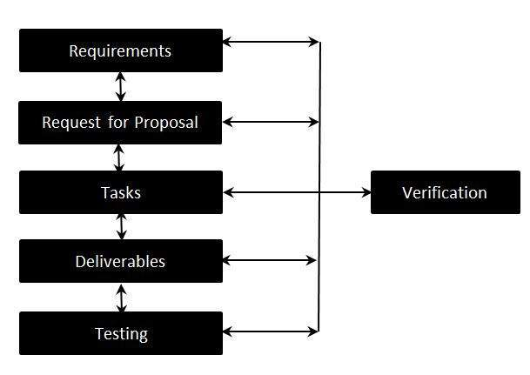

Requirement traceability Matrix - Parameters:

* Requirement ID
* Risks
* Requirement Type
* Requirement Description
* Trace to Design Specification
* Unit Test Cases
* Integration Test Cases
* System Test Cases
* User Acceptance Test Cases
* Trace to Test Script

What is an Exit Criterion?

Exit criterion is used to determine whether a given test activity has been completed or NOT. Exit criteria can be defined for all of the test activities right from planning, specification and execution.

Exit criterion should be part of test plan and decided in the planning stage.

Examples of Exit Criteria:

* Verify if All tests planned have been run.
* Verify if the level of requirement coverage has been met.
* Verify if there are NO Critical or high severity defects that are left outstanding.
* Verify if all high risk areas are completely tested.
* Verify if software development activities are completed within the projected cost.
* Verify if software development activities are completed within the projected timelines.
* **acceptance testing:**Formal testing with respect to user needs, requirements, and business processes conducted to determine  whether or not a system satisfies the acceptance criteria and to enable the user, customers or other authorized entity to determine whether or not to accept the system.

In SQL, we have the following constraints:

* **NOT NULL** - Indicates that a column cannot store NULL value
* **UNIQUE** - Ensures that each row for a column must have a unique value
* **PRIMARY KEY** - A combination of a NOT NULL and UNIQUE. Ensures that a column (or combination of two or more columns) have a unique identity which helps to find a particular record in a table more easily and quickly
* **FOREIGN KEY** - Ensure the referential integrity of the data in one table to match values in another table
* **CHECK** - Ensures that the value in a column meets a specific condition
* **DEFAULT** - Specifies a default value for a column

find duplicate records in sql

SELECT

name, email, COUNT(*)

FROM

users

GROUP BY

name, email

HAVING

COUNT(*) > 1

SQL FULL OUTER JOIN Keyword

**SQL FULL OUTER JOIN** Keyword. The **FULL OUTER JOIN** keyword returns all rows from the left table (table1) and from the right table (table2). The **FULL OUTER JOIN** keyword combines the result of both LEFT and RIGHT **joins**.

SELECT column_name(s)  
FROM table1  
FULL OUTER JOIN table2  
ON table1.column_name=table2.column_name;

## SQL INNER JOIN Keyword

The INNER JOIN keyword selects all rows from both tables as long as there is a match between the columns in both tables.

### SQL INNER JOIN Syntax

SELECT column_name(s)  
FROM table1  
INNER JOIN table2  
ON table1.column_name=table2.column_name;

or:

SELECT column_name(s)  
FROM table1  
JOIN table2  
ON table1.column_name=table2.column_name;

**PS!** INNER JOIN is the same as JOIN.

SQL CREATE VIEW Statement

In SQL, a view is a virtual table based on the result-set of an SQL statement.

A view contains rows and columns, just like a real table. The fields in a view are fields from one or more real tables in the database.

CREATE VIEW [Current Product List] AS  
SELECT ProductID,ProductName  
FROM Products  
WHERE Discontinued=No

We can query the view above as follows:

SELECT * FROM [Current Product List]

### SQL DROP VIEW Syntax

DROP VIEW view_name

**Severity** of a **defect** is related to how severe a **bug** is. Usually the **severity** is defined in terms of financial loss, damage to environment, company's reputation and loss of life. **Priority** of a **defect** is related to how quickly a **bug** should be fixed and deployed to live servers.

In software testing, defect severity can be defined as the degree of impact a defect has on the development or operation of a component application being tested.

#### Defect severity can be categorized into four class

* **Critical**: This defect indicates complete shut-down of the process, nothing can proceed further
* **Major**: It is a highly severe defect and collapse the system. However, certain parts of the system remain functional
* **Medium**: It cause some undesirable behavior, but the system is still functional
* **Low**: It won't cause any major break-down of the system

### What is Defect Priority?

Defect Priority states the order in which a defect should be fixed. Higher the priority the sooner the defect should be resolved.

#### Defect priority can be categorized into three class

* **Low:**The defect is an irritant but repair can be done once the more serious defect have been fixed
* **Medium:**During the normal course of the development activities defect should be resolved. It can wait until a new version is created
* **High:**The defect must be resolved as soon as possible as it affects the system severely and cannot be used until it is fixed

What is Agile Testing?

A software testing practice that follows the principles of agile software development is called Agile Testing. Agile is an iterative development methodology, where requirements evolve through collaboration between the customer and self-organizing teams and agile aligns development with customer needs.

Advantages of Agile Testing

* Agile Testing Saves Time and Money
* Less Documentation
* Regular feedback from the end user
* Daily meetings can help to determine the issues well in advance

Note that the term "weakness" isn't used in the sample answers —​​ you always want to focus on the positive when interviewing.

* When I'm working on a project, I don't want just to meet deadlines. Rather, I prefer to complete the project well ahead of schedule.
* Being organized wasn't my strongest point, but I implemented a time management system that really helped my organization skills.
* I like to make sure that my work is perfect, so I tend to perhaps spend a little too much time checking it. However, I've come to a good balance by setting up a system to ensure everything is done correctly the first time.
* I used to wait until the last minute to set appointments for the coming week, but I realized that scheduling in advance makes much more sense.
* Sometimes, I spend more time than necessary on a task, or take on tasks personally that could easily be delegated to someone else. Although I've never missed a deadline, it is still an effort for me to know when to move on to the next task, and to be confident when assigning others work.
* I had difficulty with calculus during college, but I persevered with tutoring assistance and extra effort and completed 2 levels with a B minus average.
* I used to like to work on one project to its completion before starting on another, but I've learned to work on many projects at the same time, and I think it allows me to be more creative and effective in each one.
* I've learned to make my perfectionism work to my advantage. I have become proficient at meeting deadlines, and with my attention to detail, I know my work is accurate.
* As an undergrad, I used to leave assignments until the last minute, but with the workload of graduate school, I learned to schedule my time very effectively.
* **1) Explain what is performance testing?**
* Performance testing is done for quality assurance. It involves testing software application to make sure that the software is working well under their expected workload.

**2) Mention different types of performance testing?**

* Load testing
* Stress testing
* Endurance testing
* Spike testing
* Volume testing
* Scalability testing

**3) List out what are the common performance problem does user face?**

* Longer loading time
* Poor response time
* Poor Scalability
* Bottlenecking (coding errors or hardware issues)

**4) List out some common performance bottlenecks?**

Some common performance bottlenecks include

* CPU Utilization
* Memory Utilization
* Networking Utilization
* S limitation
* Disk Usage

**5) List out some of the performance testing tool?**

* HP Loader
* HTTP Load
* Proxy Sniffer
* Rational Performance Tester
* JMeter
* Borland Silk Performer

**6) Why does JMeter become a natural choice of tester when it comes to performance testing?**

JMeter tool has benefits like

* It can be used for testing both static resources like HTML and JavaScript, as well as dynamic resources like Servlets, Ajax, JSP, etc.
* JMeter has a tendency to determine the maximum number of concurrent users that your website can handle
* It provides a variety of graphical analyses of performance reports

**8) List out some of the parameters considered for performance testing?**

* Memory usage
* Processor usage
* Bandwidth
* Memory pages
* Network output queue length
* Response time
* CPU interruption per second
* Committed memory
* Thread counts
* Top waits, etc.

**13) Explain what is Endurance Testing and Spike Testing?**

* **Endurance Testing:**It is one type of performance testing where the testing is conducted to evaluate the behavior of the system when a significant workload is given continuously
* **Spike Testing:**It is also a type of performance testing that is performed to analyze the behavior of the system when the load is increased substantially.

**14) Explain what are the common mistakes done in Performance Testing?**

The common mistakes done in Performance Testing are

* Direct jump to multi-user tests
* Test results not validated
* Unknown workload details
* Too small run durations
* Lacking long duration sustainability test
* Confusion on definition of concurrent users
* Data not populated sufficiently
* Significant difference between test and production environment
* Network bandwidth not simulated
* Underestimating performance testing schedules
* Incorrect extrapolation of pilots
* Inappropriate base-lining of configurations

**15) Mention the steps required in JMeter to create a performance test plan?**

To create a performance test plan in JMeter

* Add thread group
* Add JMeter elements
* Add Graph result
* Run test & get the result

**16) Explain how you can execute spike testing in JMeter?**

In JMeter, spike testing can be done by using Synchronizing Timer.  The threads are jammed by synchronizing the timer until a specific number of threads have been blocked and then release at once, creating a large instantaneous load.

**19) Mention what is the difference between the benchmark testing and baseline testing?**

* **Benchmark Testing:** It is the method of comparing performance of your system performance against an industry standard that is set by other organization
* **Baseline Testing:** It is the procedure of running a set of tests to capture performance information. When future change is made in the application, this information is used as a reference

**20) Mention what is concurrent user hits in load testing?**

In load testing, without any time difference when multiple users hit on the same event of an application under the load test is called a concurrent user hit.

**2) Explain how JMeter works?**

* JMeter acts like a group of users sending requests to a target server. It collects response from target server and other statistics which show the performance of the application or server via graphs or tables.

**5) Explain what is Samplers and Thread groups?**

* Thread group: For any test plan, JMeter is the beginning part of thread group elements. It is an important element of JMeter, where you can set number of users and time to load all the users given in the thread group
* Samplers: Sampler generates one or more sample results; these sample results have many attributes like elapsed time, data size, etc. Samplers allow JMeter to send specific types of requests to the server, through samplers, thread group decides which type of request it need to make. Some of the useful samplers are HTTP request, FTP request, JDBC request and so on.

**12) Explain what is a timer in JMeter and what are the types of it?**

* A JMeter thread by default will send requests continuously without any pause. To get a pause between the request, Timers are used. Some of the Timers used are Constant Timer, Gaussian Random Timer, Synchronizing Timer, Uniform Random Timer and so on.
* **16) Explain how you can perform spike testing in JMeter?**
* By synchronizing, timer JMeter spike testing can be achieved. Synchronizing timer, blocks thread until a specific amount of threads has been blocked and then release them all together thus creating large instantaneous load
* **21) Explain what is the role of Timer in JMeter?**
* With the help of timer, JMeter can delay the time between each request, which a thread makes. It can solve the overload problem of the server.
* **22) Explain what is Post-processor?**
* To perform any action after making a request, Post- processor is used. For example, if JMeter sends an http request to the web server, and if you want JMeter to stop sending the request if the web server shows an error, then you will use post-processor to perform this action.
* **What is risk-based testing?**

The basis of the approach is a detailed risk analysis and prioritizing of risks by risk level. Tests to address each risk are then specified, starting with the highest risk first.

* difference between preventative and reactive approaches

In **preventative approach**, **tests** are designed at an early stage, i.e. before the commencement of software development. In **Reactive approach**, **tests** are designed after software development.

* **Decision table testing?**
* In a decision table the inputs are listed in a column, with the outputs in the same column but below the inputs. The remainder of the table explores combinations of inputs to define the outputs produced.
* **What is beta testing?**
* Testing performed by potential customers at their own locations.
* **What is Alpha Testing ?**
* Alpha testing is a type of acceptance testing; performed to identify all possible issues/bugs before releasing the product to everyday users or public.
* **Rapid Application Development?**
* Rapid Application Development (RAD) is formally a parallel development of functions and subsequent integration.
* **What is component testing?**
* Component testing, also known as unit, module and program testing, searches for defects in, and verifies the functioning of software
* **What is functional system testing?**
* Testing the end to end functionality of the system as a whole is defined as a functional system testing.
* **What is random/monkey testing? When it is used?**
* Random testing often known as monkey testing. In such type of testing data is generated randomly often using a tool or automated mechanism. With this randomly generated input the system is tested and results are analysed accordingly. These testing are less reliable; hence it is normally used by the beginners and to see whether the system will hold up under adverse effects.
* **What is random/monkey testing? When it is used?**
* Random testing often known as monkey testing. In such type of testing data is generated randomly often using a tool or automated mechanism. With this randomly generated input the system is tested and results are analysed accordingly. These testing are less reliable; hence it is normally used by the beginners and to see whether the system will hold up under adverse effects.
* **What is negative and positive testing?**
* A negative test is when you put in an invalid input and receives errors. While a positive testing, is when you put in a valid input and expect some action to be completed in accordance with the specification.
* **What is the difference between re-testing and regression testing?**
* Re-testing ensures the original fault has been removed; regression testing looks for unexpected side effects.
* **What is the one Key reason why developers have difficulty testing their own work?**
* Lack of Objectivity
* **"How much testing is enough?"**
* The answer depends on the risk for your industry, contract and special requirements.
* **What is Boundary value testing?**
* Test boundary conditions on, below and above the edges of input and output equivalence classes. For instance, let say a bank application where you can withdraw maximum Rs.20,000 and a minimum of Rs.100, so in boundary value testing we test only the exact boundaries, rather than hitting in the middle.  That means we test above the maximum limit and below the minimum limit.
* **What is verification and validation?**
* Verification is a process of evaluating software  at development phase and to decide whether the product of a given  application satisfies the specified requirements. Validation is the process of evaluating software at the end of the development process and to check whether it meets the customer requirements.

**What are different test levels?**

There are four test levels

* Unit/component/program/module testing
* Integration testing
* System testing
* Acceptance testing
* **What is the difference between test scenarios, test cases and test script?**
* Difference between test scenarios and test cases is that
* **Test Scenarios:**  Test scenario is prepared before the actual testing starts, it includes plans for testing product, number of team members, environmental condition, making test cases, making test plans and all the features that are to be tested for the product.
* **Test Cases:**  It is a document that contains the steps that has to be executed, it has been planned earlier.
* **Test Script:**It is written in a programming language and it's a short program used to test part of functionality of the software system. In other words a written set of steps that should be performed manually.

**Mention what are the categories of defects?**

Mainly there are three defect categories

* **Wrong**: When requirement is implemented incorrectly
* **Missing**: It is a variance from the specification, an indication that a specification was not implemented or a requirement of the customer is not met
* **Extra**: A requirement incorporated into the product that was not given by the end customer. It is considered as a defect because it is a variance from the existing requirements

**Factorial program in c using for loop**

Here we find factorial using for loop.

#include <stdio.h>

int main()

{

int c, n, fact = 1;

printf("Enter a number to calculate it's factorial**\n**");

scanf("%d", &n);

for (c = 1; c <= n; c++)

fact = fact * c;

printf("Factorial of %d = %d**\n**", n, fact);

return 0;

}

**Fibonacci series in c using for loop**

*/* Fibonacci Series c language */*

#include<stdio.h>

int main()

{

int n, first = 0, second = 1, next, c;

printf("Enter the number of terms**\n**");

scanf("%d",&n);

printf("First %d terms of Fibonacci series are :-**\n**",n);

for ( c = 0 ; c < n ; c++ )

{

if ( c <= 1 )

next = c;

else

{

next = first + second;

first = second;

second = next;

}

printf("%d**\n**",next);

}

return 0;

}

# Program to display the Fibonacci sequence up to n-th term where n is provided by the user

# change this value for a different result

nterms = 10

# uncomment to take input from the user

#nterms = int(input("How many terms? "))

# first two terms

n1 = 0

n2 = 1

count = 2

# check if the number of terms is valid

if nterms <= 0:

print("Please enter a positive integer")

elif nterms == 1:

print("Fibonacci sequence upto",nterms,":")

print(n1)

else:

print("Fibonacci sequence upto",nterms,":")

print(n1,",",n2,end=', ')

while count < nterms:

nth = n1 + n2

print(nth,end=' , ')

# update values

n1 = n2

n2 = nth

count += 1

**Palindrome number in c**

#include <stdio.h>

main()

{

int n, reverse = 0, temp;

printf("Enter a number to check if it is a palindrome or not**\n**");

scanf("%d",&n);

temp = n;

while (temp != 0)

{

reverse = reverse * 10;

reverse = reverse + temp%10;

temp = temp/10;

}

if (n == reverse)

printf("%d is a palindrome number.**\n**", n);

else

printf("%d is not a palindrome number.**\n**", n);

return 0;

}

#include <stdio.h>

#include <string.h>

int main()

{

char string1[20];

int i, length;

int flag = 0;

printf("Enter a string:");

scanf("%s", string1);

length = strlen(string1);

for(i=0;i < length ;i++)

{

if(string1[i] != string1[length-i-1])

{ flag = 1;

break;

}

}

if (flag)

{

printf("%s is not a palindrome", string1);

}

else

{

printf("%s is a palindrome", string1);

}

return 0;

}

SQL AVG() Example

SELECT ProductName, Price FROM Products  
WHERE Price>(SELECT AVG(Price) FROM Products);

select DEPARTMENT,count(STAFF_ID) as CountStaff, avg(SALARY) as AVGSalary

from STAFF

group by DEPARTMENT

having count(STAFF_ID) > 5

how to find out 3rd maximum value using sql server

SELECT TOP 1 salary FROM (

SELECT TOP 3 salary

FROM employees

ORDER BY salary DESC) AS emp

ORDER BY salary ASC

### [Difference between TRUNCATE and DELETE commands](http://www.orafaq.com/comment/1869#comment-1869)

[**Permalink**](http://www.orafaq.com/comment/1869#comment-1869) Submitted by Dipal havsar (not verified) on Tue, 2006-09-19 08:39.

1>TRUNCATE is a DDL command whereas DELETE is a DML command.

2>TRUNCATE is much faster than DELETE.

Reason:When you type DELETE.all the data get copied into the Rollback Tablespace first.then delete operation get performed.Thatswhy when you type ROLLBACK after deleting a table ,you can get back the data(The system get it for you from the Rollback Tablespace).All this process take time.But when you type TRUNCATE,it removes data directly without copying it into the Rollback Tablespace.Thatswhy TRUNCATE is faster.Once you Truncate you cann't get back the data.

3>You cann't rollback in TRUNCATE but in DELETE you can rollback.TRUNCATE removes the record permanently.

4>In case of TRUNCATE ,Trigger doesn't get fired.But in DML commands like DELETE .Trigger get fired.

5>You cann't use conditions(WHERE clause) in TRUNCATE.But in DELETE you can write conditions using WHERE clause

You are now going to learn about the Dictionary data structure in Python. A Dictionary (or "dict") is a way to store data just like a list, but instead of using only numbers to get the data, you can use almost anything. This lets you treat a dict like it's a database for storing and organizing data.

>>> stuff **=** {'name': 'Zed', 'age': 39, 'height': 6 **\*** 12 **+** 2}

>>> **print** stuff['name']

Zed

>>> **print** stuff['age']

39

>>> **print** stuff['height']

74

>>> stuff['city'] **=** "San Francisco"

>>> **print** stuff['city']

San Francisco

states **=** {

'Oregon': 'OR',

'Florida': 'FL',

'California': 'CA',

'New York': 'NY',

'Michigan': 'MI'

}

Dictionaries are another example of a data structure, and like lists they are one of the most commonly used data structures in programming. A dictionary is used to map or associate things you want to store to keys you need to get them. Again, programmers don't use a term like "dictionary" for something that doesn't work like an actual dictionary full of words, so let's use that as our real world example.

# C# Access Modifiers , C# Access Specifiers

**Access Modifiers (Access Specifiers)** describes as the scope of accessibility of an Object and its members. All C# types and type members have an accessibility level . We can control the scope of the member object of a class using access specifiers. We are using access modifiers for providing security of our applications. When we specify the accessibility of a type or member we have to declare it by using any of the access modifiers provided by [CSharp](http://csharp.net-informations.com/) language.

C# provide five access specifiers , they are as follows :

***public, private , protected , internal and protected internal*** .

**public :**

public is the most common access specifier in C# . It can be access from anywhere, that means there is no restriction on accessibility. The scope of the accessibility is inside class as well as outside. The type or member can be accessed by any other code in the same assembly or another assembly that references it.

**private :**

The scope of the accessibility is limited only inside the classes or struct in which they are declared. The private members cannot be accessed outside the class and it is the least permissive access level.

**protected :**

The scope of accessibility is limited within the class or struct and the class derived (Inherited )from this class.

**internal :**

The internal access modifiers can access within the program that contain its declarations and also access within the same assembly level but not from another assembly.

**protected internal :**

Protected internal is the same access levels of both protected and internal. It can access anywhere in the same assembly and in the same class also the classes inherited from the same class .

**What is the difference between list and tuple in Python?**

To put it lightly, tuples are lists which can't be edited. Once you create a tuple, you cannot edit it, it is immutable. Lists on the other hand are mutable, you can edit them, they work like the array object in JavaScript or PHP. You can add items, delete items from a list; but you can't do that to a tuple, tuples have a fixed size.

Here is an example demonstrating the mutable nature of lists in Python.

>>> animals = ['cat', 'dog']  
>>> animals  
['cat', 'dog']  
>>> animals.append('mat')  
>>> animals  
['cat', 'dog', 'mat']  
>>> animals[2] = 'bat'  
>>> animals  
['cat', 'dog', 'bat']

An example showing the immutable nature of tuples in Python.

>>> point = (3,7)  
>>> point  
(3, 7)  
>>> point[1]  
7  
>>> point[1] = 4  
Traceback (most recent call last):  
 File "", line 1, in   
TypeError: 'tuple' object does not support item assignment

Object Oriented Programming is based on the following concepts:

1. **Classes of objects**.
2. **Instances of classes** (objects).
3. **Encapsulation** - a class encapsulates all the fields and functions that are performed on the fields of a class. The results of encapsulation are:
   * Restriction to access some of the object's data from outside of class.
   * Bundling data to functions inside a class.

The encapsulation is described in details in "C++ Encapsulation" topic.

1. **Polymorphism** - a way to use the same interface for the different data types. In simple words it can be described as using the same name for member functions that have different arguments. Polymorphism is not only related to member functions. It's discussed in more details in "C++ Polymorphism"
2. **Inheritance** - a class can inherit some properties from another class. This means that a child class can use some of the functionality of parent class. You can find more information about inheritance in C++ Inheritance.
3. **Abstraction** - consists in hiding the details of some processes and data and representing only necessary information and result outside the class. The detailed description of the abstraction concept can be found in "C++ Abstraction".
4. **Overloading** - represents a kind of polymorphism. There is a possibility to overload already existing functions and operators to make them work with new data types. The overloading is described in "C++ Overloading"
5. **Error handling** - some of the errors can appear in run time. Because of this, there is a need to handle errors to make programs safe. The mechanism of C++ error handling is described in "C++ Exception Handling".

## Python's range() Function Examples

#### Simple Usage

|  |  |
| --- | --- |
| 1  2  3  4  5  6  7  8  9  10  11  12  13  14  15  16  17  18  19  20  21  22  23  24  25  26  27  28  29  30  31  32 | >>> # One parameter  >>> for i in range(5):  ...     print(i)  ...  0  1  2  3  4  >>> # Two parameters  >>> for i in range(3, 6):  ...     print(i)  ...  3  4  5  >>> # Three parameters  >>> for i in range(4, 10, 2):  ...     print(i)  ...  4  6  8  >>> # Going backwards  >>> for i in range(0, -10, -2):  ...     print(i)  ...  0  -2  -4  -6  -8 |

#### Iterating Lists

|  |  |
| --- | --- |
| 1  2  3  4  5  6  7  8  9  10 | >>> my_list = ['one', 'two', 'three', 'four', 'five']  >>> my_list_len = len(my_list)  >>> for i in range(0, my_list_len):  ...     print(my_list[i])  ...  one  two  three  four  five |

Program : Reverse String Without Using Library Function [ Strrev ]



|  |  |
| --- | --- |
| 1  2  3  4  5  6  7  8  9  10  11  12  13  14  15  16  17  18  19  20  21  22  23  24 | #include<stdio.h>  #include<string.h>    int main() {     char str[100], temp;     int i, j = 0;       printf("\nEnter the string :");     gets(str);       i = 0;     j = strlen(str) - 1;       while (i < j) {        temp = str[i];        str[i] = str[j];        str[j] = temp;        i++;        j--;     }       printf("\nReverse string is :%s", str);     return (0);  } |

## SQL Injection

SQL injection is a technique where malicious users can inject SQL commands into an SQL statement, via web page input.

Injected SQL commands can alter SQL statement and compromise the security of a web application.

## SQL Injection Based on 1=1 is Always True

Look at the example above, one more time.

Let's say that the original purpose of the code was to create an SQL statement to select a user with a given user id.

If there is nothing to prevent a user from entering "wrong" input, the user can enter some "smart" input like this:

UserId:   


### Server Result

SELECT * FROM Users WHERE UserId = 105 or 1=1;

The SQL above is valid. It will return all rows from the table Users, since **WHERE 1=1** is always true.

Does the example above seem dangerous? What if the Users table contains names and passwords?

The SQL statement above is much the same as this:

SELECT UserId, Name, Password FROM Users WHERE UserId = 105 or 1=1;

A smart hacker might get access to all the user names and passwords in a database by simply inserting 105 or 1=1 into the input box.

## SQL Injection Based on ""="" is Always True

Here is a common construction, used to verify user login to a web site:

User Name:  


Password:  


### Server Code

uName = getRequestString("UserName");  
uPass = getRequestString("UserPass");  
  
sql = 'SELECT * FROM Users WHERE Name ="' + uName + '" AND Pass ="' + uPass + '"'

### Result

SELECT * FROM Users WHERE Name ="John Doe" AND Pass ="myPass"

A smart hacker might get access to user names and passwords in a database by simply inserting " or ""=" into the user name or password text box:

User Name:  


Password:  


The code at the server will create a valid SQL statement like this:

### Result

SELECT * FROM Users WHERE Name ="" or ""="" AND Pass ="" or ""=""

The result SQL is valid. It will return all rows from the table Users, since **WHERE ""=""** is always true.

## SQL Injection Based on Batched SQL Statements

Most databases support batched SQL statement, separated by semicolon.

### Example

SELECT * FROM Users; DROP TABLE Suppliers

The SQL above will return all rows in the Users table, and then delete the table called Suppliers.

If we had the following server code:

### Server Code

txtUserId = getRequestString("UserId");  
txtSQL = "SELECT * FROM Users WHERE UserId = " + txtUserId;

And the following input:

User id:  


The code at the server would create a valid SQL statement like this:

### Result

SELECT * FROM Users WHERE UserId = 105; DROP TABLE Suppliers

## Parameters for Protection

Some web developers use a "blacklist" of words or characters to search for in SQL input, to prevent SQL injection attacks.

This is not a very good idea. Many of these words (like delete or drop) and characters (like semicolons and quotation marks), are used in common language, and should be allowed in many types of input.

(In fact it should be perfectly legal to input an SQL statement in a database field.)

The only proven way to protect a web site from SQL injection attacks, is to use SQL parameters.

SQL parameters are values that are added to an SQL query at execution time, in a controlled manner.

### ASP.NET Razor Example

txtUserId = getRequestString("UserId");  
txtSQL = "SELECT * FROM Users WHERE UserId = @0";  
db.Execute(txtSQL,txtUserId);

**VERAFIED Security Mark for the OWASP TOP 10**

|  |  |  |
| --- | --- | --- |
| [A1](https://www.owasp.org/index.php/Top_10_2013-A1-Injection) | Injection | **X** |
| [A2](https://www.owasp.org/index.php/Top_10_2013-A2-Broken_Authentication_and_Session_Management) | Broken Authentication and Session Management ([XSS](https://www.veracode.com/security/xss)) | **X** |
| [A3](https://www.owasp.org/index.php/Top_10_2013-A3-Cross-Site_Scripting_(XSS)) | Cross Site Scripting (XSS) | **X** |
| [A4](https://www.owasp.org/index.php/Top_10_2013-A4-Insecure_Direct_Object_References) | Insecure Direct Object References | **X** |
| [A5](https://www.owasp.org/index.php/Top_10_2013-A5-Security_Misconfiguration) | Security Misconfiguration |  |
| [A6](https://www.owasp.org/index.php/Top_10_2013-A6-Sensitive_Data_Exposure) | Sensitive Data Exposure | **X** |
| [A7](https://www.owasp.org/index.php/Top_10_2013-A7-Missing_Function_Level_Access_Control) | Missing Function Level Access Control | **X** |
| [A8](https://www.owasp.org/index.php/Top_10_2013-A8-Cross-Site_Request_Forgery_(CSRF)) | Cross Site Request Forgery (CSRF) |  |
| [A9](https://www.owasp.org/index.php/Top_10_2013-A9-Using_Components_with_Known_Vulnerabilities) | Using Components with Known Vulnerabilities |  |
| [A10](https://www.owasp.org/index.php/Top_10_2013-A10-Unvalidated_Redirects_and_Forwards) | Unvalidated Redirects and Forwards |  |

# 4.1 Adding Users

The first step you want to do with every JMeter Test Plan is to add a [Thread Group](http://jmeter.apache.org/usermanual/test_plan.html#thread_group) element. The Thread Group tells JMeter the number of users you want to simulate, how often the users should send requests, and how many requests they should send.

Go ahead and add the ThreadGroup element by first selecting the Test Plan, clicking your right mouse button to get the Add menu, and then select Add → ThreadGroup.

You should now see the Thread Group element under Test Plan. If you do not see the element, then "expand" the Test Plan tree by clicking on the Test Plan element.

Next, you need to modify the default properties. Select the Thread Group element in the tree, if you have not already selected it. You should now see the Thread Group Control Panel in the right section of the JMeter window (see Figure 4.1 below)

[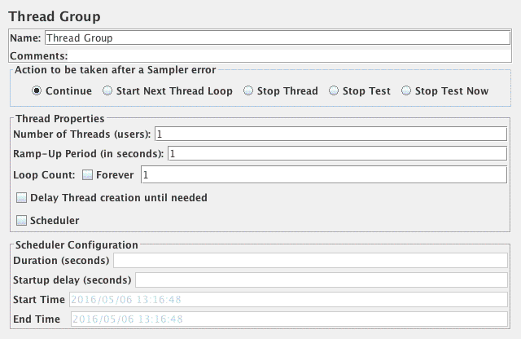](http://jmeter.apache.org/images/screenshots/webtest/threadgroup.png)Figure 4.1. Thread Group with Default Values

Start by providing a more descriptive name for our Thread Group. In the name field, enter JMeter Users.

Next, increase the number of users (called threads) to 5.

In the next field, the Ramp-Up Period, leave the default value of 1 seconds. This property tells JMeter how long to delay between starting each user. For example, if you enter a Ramp-Up Period of 5 seconds, JMeter will finish starting all of your users by the end of the 5 seconds. So, if we have 5 users and a 5 second Ramp-Up Period, then the delay between starting users would be 1 second (5 users / 5 seconds = 1 user per second). If you set the value to 0, then JMeter will immediately start all of your users.

Finally enter a value of 2 in the Loop Count field. This property tells JMeter how many times to repeat your test. If you enter a loop count value of 1, then JMeter will run your test only once. To have JMeter repeatedly run your Test Plan, select the Forever checkbox.

In most applications, you have to manually accept changes you make in a Control Panel. However, in JMeter, the Control Panel automatically accepts your changes as you make them. If you change the name of an element, the tree will be updated with the new text after you leave the Control Panel (for example, when selecting another tree element).

See Figure 4.2 for the completed JMeter Users Thread Group.

[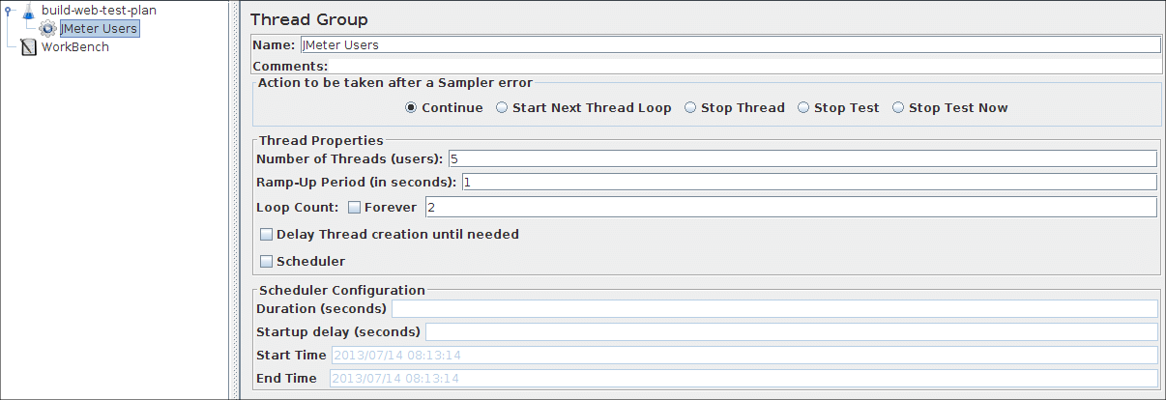](http://jmeter.apache.org/images/screenshots/webtest/threadgroup2.png)Figure 4.2. JMeter Users Thread Group

# 4.2 Adding Default HTTP Request Properties

Now that we have defined our users, it is time to define the tasks that they will be performing. In this section, you will specify the default settings for your HTTP requests. And then, in section 4.3, you will add HTTP Request elements which use some of the default settings you specified here.

Begin by selecting the JMeter Users (Thread Group) element. Click your right mouse button to get the Add menu, and then select Add → Config Element → HTTP Request Defaults. Then select this new element to view its Control Panel (see Figure 4.3).

[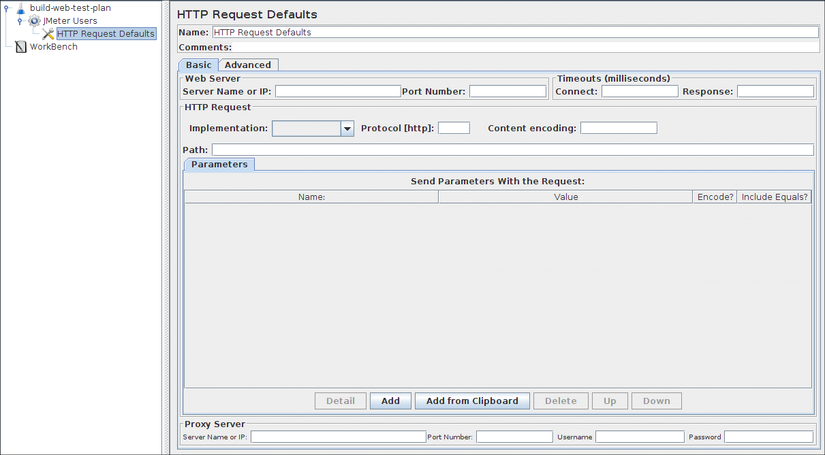](http://jmeter.apache.org/images/screenshots/webtest/http-defaults1.png)Figure 4.3. HTTP Request Defaults

Like most JMeter elements, the [HTTP Request Defaults](http://jmeter.apache.org/usermanual/component_reference.html#HTTP_Request_Defaults) Control Panel has a name field that you can modify. In this example, leave this field with the default value.

Skip to the next field, which is the Web Server's Server Name/IP. For the Test Plan that you are building, all HTTP requests will be sent to the same Web server, jmeter.apache.org. Enter this domain name into the field. This is the only field that we will specify a default, so leave the remaining fields with their default values.

The HTTP Request Defaults element does not tell JMeter to send an HTTP request. It simply defines the default values that the HTTP Request elements use.

See Figure 4.4 for the completed HTTP Request Defaults element

Figure 4.4. HTTP Defaults for our Test Plan

# 4.3 Adding Cookie Support

Nearly all web testing should use cookie support, unless your application specifically doesn't use cookies. To add cookie support, simply add an [HTTP Cookie Manager](http://jmeter.apache.org/usermanual/component_reference.html#HTTP_Cookie_Manager) to each [Thread Group](http://jmeter.apache.org/usermanual/test_plan.html#thread_group) in your test plan. This will ensure that each thread gets its own cookies, but shared across all [HTTP Request](http://jmeter.apache.org/usermanual/component_reference.html#HTTP_Request) objects.

To add the [HTTP Cookie Manager](http://jmeter.apache.org/usermanual/component_reference.html#HTTP_Cookie_Manager), simply select the [Thread Group](http://jmeter.apache.org/usermanual/test_plan.html#thread_group), and choose Add → Config Element → HTTP Cookie Manager, either from the Edit Menu, or from the right-click pop-up menu.

# 4.4 Adding HTTP Requests

In our Test Plan, we need to make two HTTP requests. The first one is for the JMeter home page (http://jmeter.apache.org/), and the second one is for the Changes page (http://jmeter.apache.org/changes.html).

JMeter sends requests in the order that they appear in the tree.

Start by adding the first [HTTP Request](http://jmeter.apache.org/usermanual/component_reference.html#HTTP_Request) to the JMeter Users element (Add → Sampler → HTTP Request). Then, select the HTTP Request element in the tree and edit the following properties (see Figure 4.5):

1. Change the Name field to "Home Page".
2. Set the Path field to "/". Remember that you do not have to set the Server Name field because you already specified this value in the HTTP Request Defaults element.

[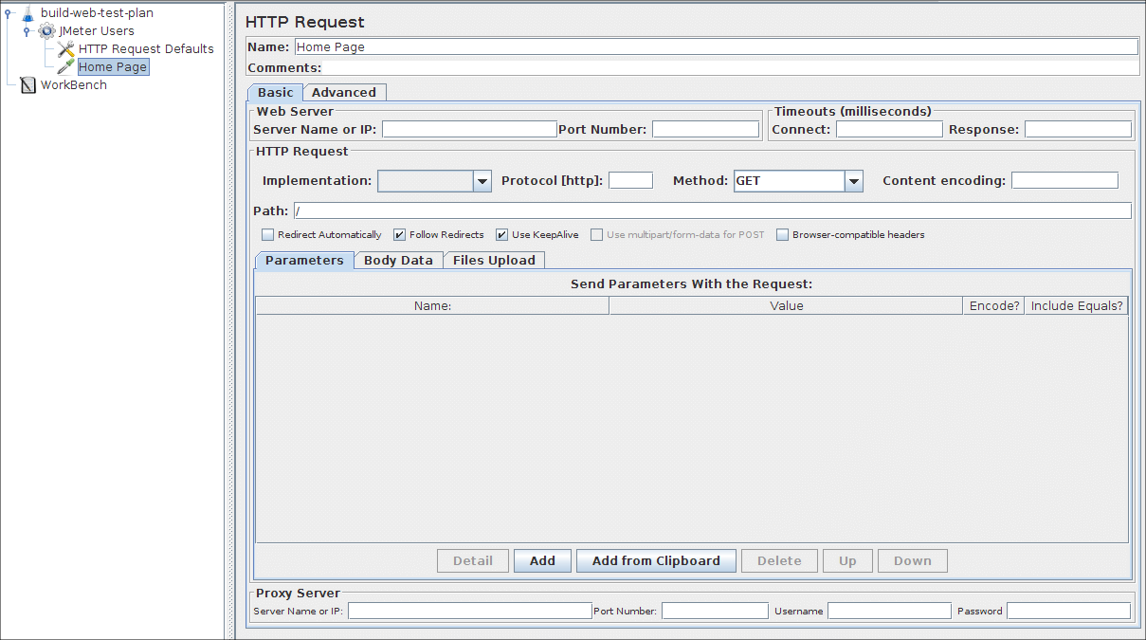](http://jmeter.apache.org/images/screenshots/webtest/http-request1.png)Figure 4.5. HTTP Request for JMeter Home Page

Next, add the second HTTP Request and edit the following properties (see Figure 4.6:

1. Change the Name field to "Changes".
2. Set the Path field to "/changes.html".

Figure 4.6. HTTP Request for JMeter Changes Page

# 4.5 Adding a Listener to View Store the Test Results

The final element you need to add to your Test Plan is a [Listener](http://jmeter.apache.org/usermanual/component_reference.html#listeners). This element is responsible for storing all of the results of your HTTP requests in a file and presenting a visual model of the data.

Select the JMeter Users element and add a [Graph Results](http://jmeter.apache.org/usermanual/component_reference.html#Graph_Results) listener (Add → Listener → Graph Results). Next, you need to specify a directory and filename of the output file. You can either type it into the filename field, or select the Browse button and browse to a directory and then enter a filename.

[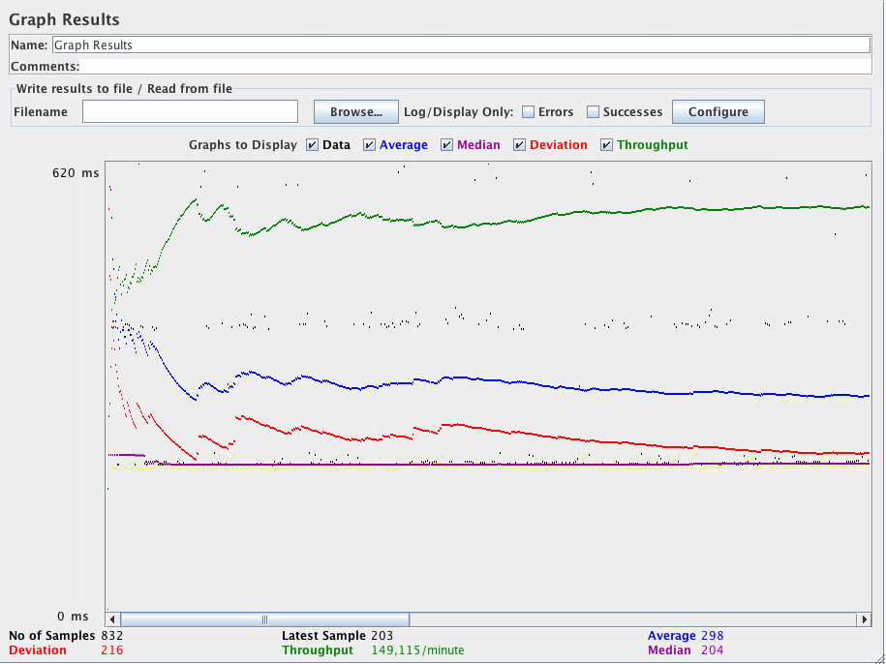](http://jmeter.apache.org/images/screenshots/graph_results.png)Figure 4.7. Graph Results Listener

# 4.6 Logging in to a web-site

It's not the case here, but some web-sites require you to login before permitting you to perform certain actions. In a web-browser, the login will be shown as a form for the user name and password, and a button to submit the form. The button generates a POST request, passing the values of the form items as parameters.

To do this in JMeter, add an HTTP Request, and set the method to POST. You'll need to know the names of the fields used by the form, and the target page. These can be found out by inspecting the code of the login page. [If this is difficult to do, you can use the [JMeter Proxy Recorder](http://jmeter.apache.org/usermanual/component_reference.html#HTTP_Proxy_Server) to record the login sequence.] Set the path to the target of the submit button. Click the Add button twice and enter the username and password details. Sometimes the login form contains additional hidden fields. These will need to be added as well.

[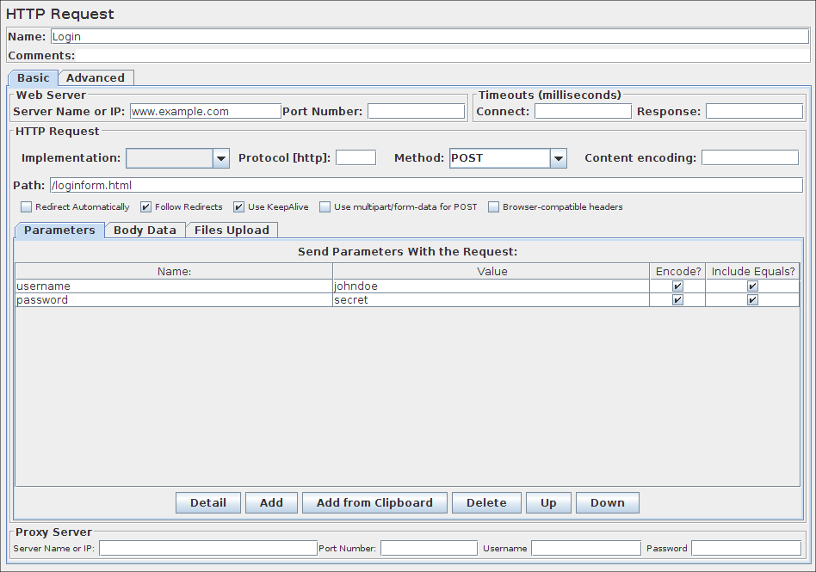](http://jmeter.apache.org/images/screenshots/webtest/http_login.png)Figure 4.8. Sample HTTP login request

## 3.3 Listeners

Listeners provide access to the information JMeter gathers about the test cases while JMeter runs. The[Graph Results](http://jmeter.apache.org/usermanual/component_reference.html#Graph_Results) listener plots the response times on a graph. The "View Results Tree" Listener shows details of sampler requests and responses, and can display basic HTML and XML representations of the response. Other listeners provide summary or aggregation information.

Additionally, listeners can direct the data to a file for later use. Every listener in JMeter provides a field to indicate the file to store data to. There is also a Configuration button which can be used to choose which fields to save, and whether to use CSV or XML format.

Note that all Listeners save the same data; the only difference is in the way the data is presented on the screen.

Listeners can be added anywhere in the test, including directly under the test plan. They will collect data only from elements at or below their level.

There are several [listeners](http://jmeter.apache.org/usermanual/component_reference.html#listeners) that come with JMeter.

## 3.4 Timers

By default, a JMeter thread executes samplers in sequence without pausing. We recommend that you specify a delay by adding one of the available timers to your Thread Group. If you do not add a delay, JMeter could overwhelm your server by making too many requests in a very short amount of time.

A timer will cause JMeter to delay a certain amount of time **before** each sampler which is in its [scope](http://jmeter.apache.org/usermanual/test_plan.html#scoping_rules).

If you choose to add more than one timer to a Thread Group, JMeter takes the sum of the timers and pauses for that amount of time before executing the samplers to which the timers apply. Timers can be added as children of samplers or controllers in order to restrict the samplers to which they are applied.

To provide a pause at a single place in a test plan, one can use the [Test Action](http://jmeter.apache.org/usermanual/component_reference.html#Test_Action) Sampler.

## 3.7 Pre-Processor Elements

A Pre-Processor executes some action prior to a Sampler Request being made. If a Pre-Processor is attached to a Sampler element, then it will execute just prior to that sampler element running. A Pre-Processor is most often used to modify the settings of a Sample Request just before it runs, or to update variables that aren't extracted from response text. See the [**scoping rules**](http://jmeter.apache.org/usermanual/test_plan.html#scoping_rules) for more details on when Pre-Processors are executed.

## 3.8 Post-Processor Elements

A Post-Processor executes some action after a Sampler Request has been made. If a Post-Processor is attached to a Sampler element, then it will execute just after that sampler element runs. A Post-Processor is most often used to process the response data, often to extract values from it. See the [**scoping rules**](http://jmeter.apache.org/usermanual/test_plan.html#scoping_rules) for more details on when Post-Processors are executed.

**Program 1- Write a program which will capture System Date**



|  |  |
| --- | --- |
| 1  2  3  4  5  6  7  8  9  10  11  12  13  14  15  16  17  18  19  20  21  22  23  24  25 | package demo;    import java.text.DateFormat;  import java.text.SimpleDateFormat;  import java.util.Date;    public class GetDateinJava {    public static void main(String[] args) {    // Create object of SimpleDateFormat class and decide the format  DateFormat dateFormat = new SimpleDateFormat("MM/dd/yyyy ");    //get current date time with Date()  Date date = new Date();    // Now format the date  String date1= dateFormat.format(date);    // Print the Date  System.out.println(date1);    }    } |

**Program 2- Write a program which will capture System Date/ Time**

In this example I am taking time as well so I have added HH:MM:SS also in format



|  |  |
| --- | --- |
| 1  2  3  4  5  6  7  8  9  10  11  12  13  14  15  16  17  18  19  20  21  22  23  24  25 | package demo;    import java.text.DateFormat;  import java.text.SimpleDateFormat;  import java.util.Date;    public class GetDateinJava {    public static void main(String[] args) {    // Create object of SimpleDateFormat class and decide the format  DateFormat dateFormat = new SimpleDateFormat("MM/dd/yyyy HH:mm:ss");    //get current date time with Date()  Date date = new Date();    // Now format the date  String date1= dateFormat.format(date);    // Print the Date  System.out.println("Current date and time is " +date1);    }    } |

* Recovery: As the word suggest, coming back on to the normal stage from any of the damaged situation.
* For example, we can say that if tests are dependent on each other and due to any runtime exception test pause or hang then this affects dependent test execution also and here the situation is critical.
* Continuous monitoring of test execution, proper and informative logging, thorough reporting and maintaining history. Can makes life easy for Recovery.
* So, we can say that in order to be able to achieve success during recoveries, we need to implement logs, exceptions, history of execution state and reporting very smartly.
* “SANPSHOTS” and “MAIL” components are the left and right hand of this component.
* Sometimes, these unwanted responses can lead to critical bugs and here SNAPSHOTS and MAILS are very useful components for any of the framework.
* So, we can say that in order to be able to achieve success during recoveries, we need to implement logs, exceptions, history of execution state and reporting very smartly.
* “SANPSHOTS” and “MAIL” components are the left and right hand of this component.
* Sometimes, these unwanted responses can lead to critical bugs and here SNAPSHOTS and MAILS are very useful components for any of the framework.

### Pop up Window: –

* Pop up window arrives unexpectedly during execution.
* Pop up window streaming too fast that automation not able to capture it.
* Pop up window handle is not able to pick by automation suite.
* Pop up window makes application hang first and then the system.
* Login password pop up, automation locators are not correct and throw error and we cannot move further. We want to stop this test and move further to next one.
* Test suite design issue handles pop up at wrong place and stops execution.

### Object State: –

* Object attributes are not fetched at correct time and execution moves on and throwing errors.
* Object is not on the page and can be the reason of wrong locator or wrong code or page is not yet loaded.
* In state scenario it totally depends on the state of the object on which automation suite is playing and resulting into unwanted response or exception which sometimes or usually handled by waits also.

### Test Run Error: –

* These errors handling is totally customized as it can happen the trigger of exception is not Application under automation it can be the other factors like accessing system resources, third party tools, network issues, file handling, reporting or internal framework architectural issues, input files naming conventions, format templates for test data etc.
* Test run error can unexpectedly comes up when test scenarios are not written as per the requirements or major bug found in application which is not at all predicted by the automation suite.
* These test run errors can be captured through exceptions only and surely it will take time and experience to put under all these kind of scenarios under one roof.

### Application Crash: –

* This crash factor is something which rarely occurs and usually when system requirement and other entity requirements like compatible browser etc or we can say pre requisite to run automation are not matched and leads to no response from Application, Automation Suite or other resources.

### Synchronization Issues: –

* Synchronization wait checkpoint if not configured the correctly then they lead to Exceptions

### Keyboard & Mouse Operations:

### Snapshots: –

* Taking snapshot after catching exception for recovery pre operation gives us the chance to evaluate the situation of the application at that instance visually that what actually happens at time.
* Snapshot is useful to analyze the specific object state on the page.
* Snapshot is useful to show n tell in future or can be studied further for knowledge capitalization.
* Snapshot gives us the confidence that the problem is at Application side not at Automation and it can be vice versa also which gives us opportunity to make our suite more improved.

Mails: –

* Will surely provide alerts in just a minute that what is going on.
* Mails configuration as per the needs gives us the opportunity to flow information with other stake holders also.
* Configuring Mails Test team, Client, Developers, High Level Mgmt etc as per the needs makes us flexible that if Exceptions or Critical scenarios studied well and correct information will deliver to correct stake holders.
* Mails can be used to share the deliverables (logs, reports etc) quickly at those instances with everyone during any
* Go to the Jenkins dashboard and Click on New Item
* 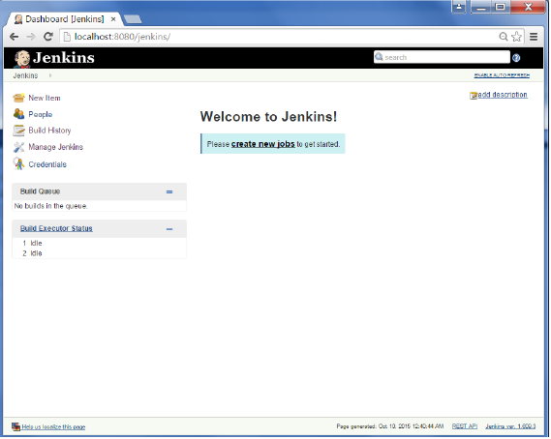
* **Step 2** − In the next screen, enter the Item name, in this case we have named it Helloworld. Choose the ‘Freestyle project option’
* 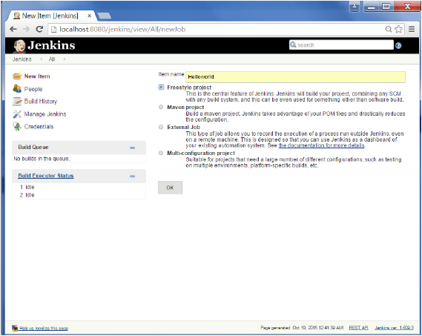
* **Step 3** − The following screen will come up in which you can specify the details of the job.
* 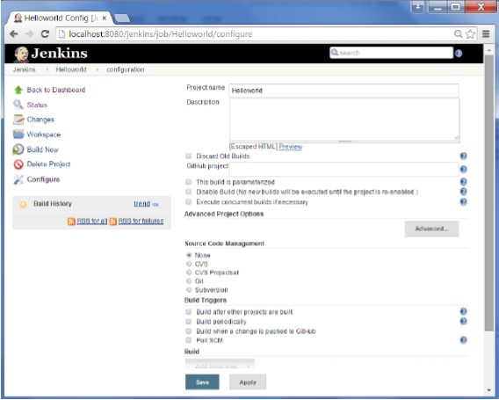
* **Step 4** − We need to specify the location of files which need to be built. In this example, we will assume that a local git repository(E:\Program) has been setup which contains a ‘HelloWorld.java’ file. Hence scroll down and click on the Git option and enter the URL of the local git repository.
* **Note** − If you repository if hosted on Github, you can also enter the url of that repository here. In addition to this, you would need to click on the Add button for the credentials to add a user name and password to the github repository so that the code can be picked up from the remote repository.
* 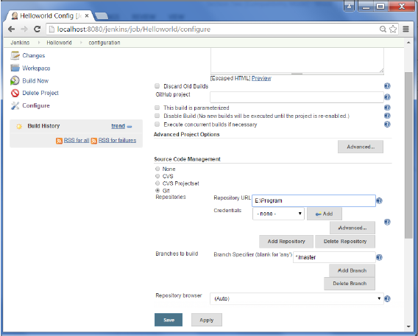
* **Step 5** − Now go to the Build section and click on Add build step → Execute Windows batch command
* 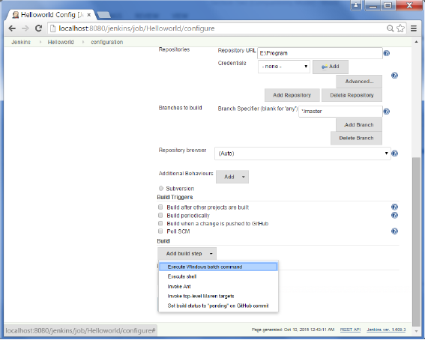
* **Step 6** − In the command window, enter the following commands and then click on the Save button.
* Javac HelloWorld.java
* Java HelloWorld
* 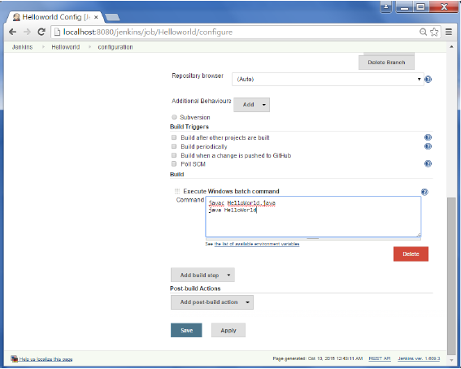
* **Step 7** − Once saved, you can click on the Build Now option to see if you have successfully defined the job.
* 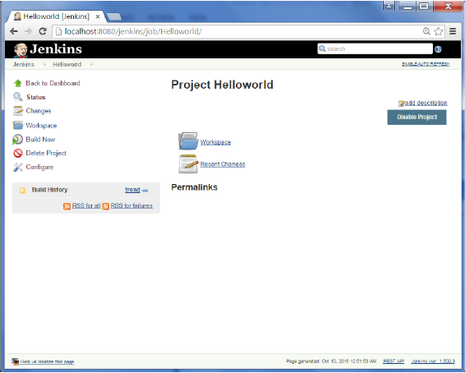
* **Step 8** − Once the build is scheduled, it will run. The following Build history section shows that a build is in progress.
* 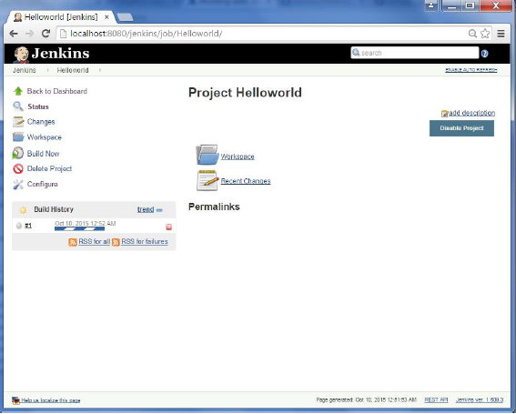
* **Step 9** − Once the build is completed, a status of the build will show if the build was successful or not. In our case, the following build has been executed successfully. Click on the #1 in the Build history to bring up the details of the build.
* 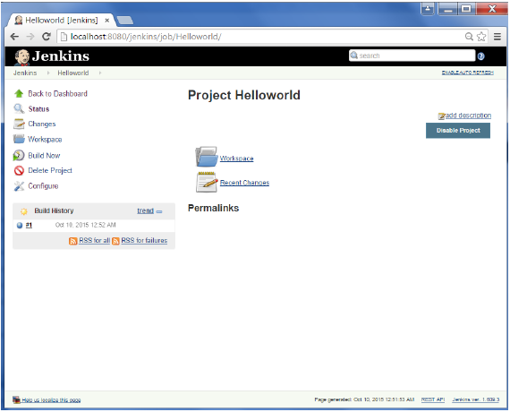
* **Step 10** − Click on the Console Output link to see the details of the build
* 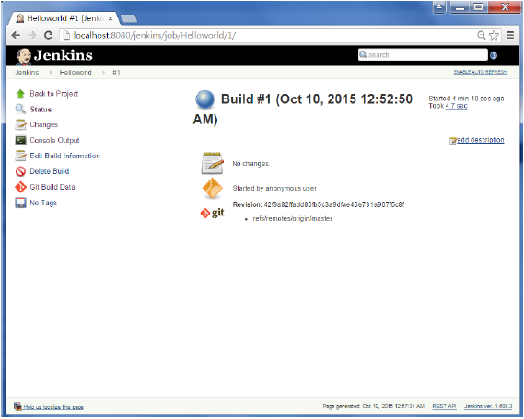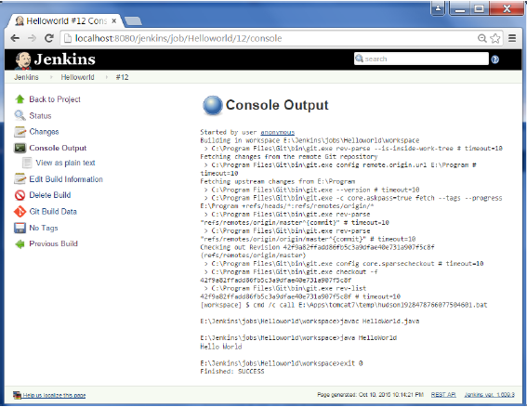
* Apart from the steps shown above there are just so many ways to create a build job, the options available are many, which what makes Jenkins such a fantastic continuous deployment tool.

**Jenkins deployment**

Download jenkins .war file from [here](https://jenkins-ci.org/) (column on the right side of the page, under Java Web Archive (.war)section) and save it to your$CATALINA_HOME/webapps/ directory. Now you can run tomcat (or restart it, if you didn’t shut it down with shutdown.sh script):

sh startup.sh

…and open http://localhost:8080/jenkins in your browser. You should see Jenkins up and running (jobs list can differ):

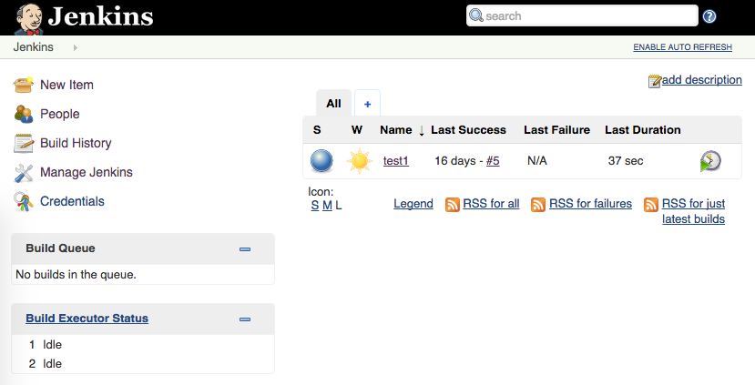

**Job configuration**

As a reminder, our task is to create a job to clone repository, run tests and publish report. We will use repository with Selenium acceptance test from my [github](https://github.com/lroslonek/SportsDirectTest). First of all, we have to add Git plugin. To do so:

1. click on the Manage Jenkinson the left
2. go to Manage plugins and change tab to Available
3. filter list with *GIT plugin*
4. mark checkbox next to GIT plugin
5. click Install without restart
6. click Go back to the top page

Now lets start creating new job:

1. click New Item on the left
2. type the name of the job
3. check Freestyle project
4. click OK

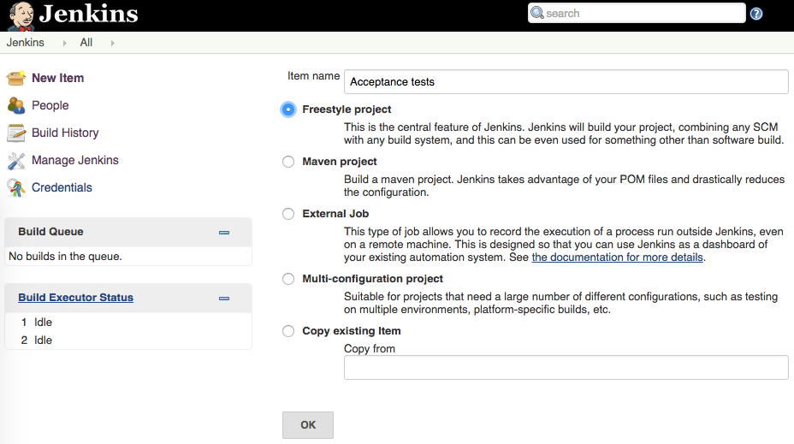

You should be redirected to configuration page of your job. Lets create step definitions for our job:

1. under source code management select Git
2. under Repository URLpaste following: https://github.com/lroslonek/SportsDirectTest.git
3. in Build section click on the Add build step button and select: execute shell
4. in the command text box paste following: *./gradlew clean test*
5. in Post-build Actions section click on the Add post-build step button and select: Publish JUnit test result report
6. underTest report XMLspaste following: build/test-results/*.xml
7. click Save

So let me explain what happened here. Basicly we’ve created new Jenkins job and configured it. In steps 1-2 we’ve choosed Git as a version control system for our repository, and point to our repository URL. In steps 3-4 we’ve defined action to run ./gradlew clean test script, that runs tests from the project (gradlew is a wrapper to download newest gradle distribution). In steps 5-6 we’ve told Jenkins to look for the xml test reports in build/test-results directory, and publish them in job’s build results view.

After configuration is done, we can run our brand new job and check test results. To run the job, click on the Build Now link on the left. You should see progress bar in the Build History section, which means that our build is in progress (firefox should open up, since it’s implementation is used in selenium project which we run):

[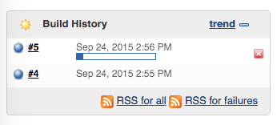](http://testdetective.com/wp-content/uploads/2015/09/Screen-Shot-2015-09-24-at-14.56.18.png)

When build is completed, you can click on the build number in Build History section and check result of the specific build. From here you can see console output of the job worker:

[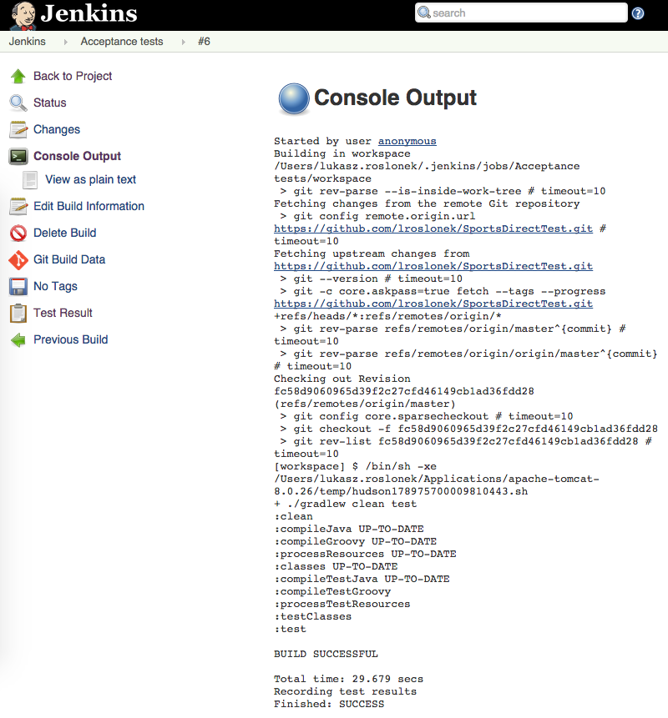](http://testdetective.com/wp-content/uploads/2015/09/Screen-Shot-2015-09-24-at-15.31.14.png)

…or see the tests result:

[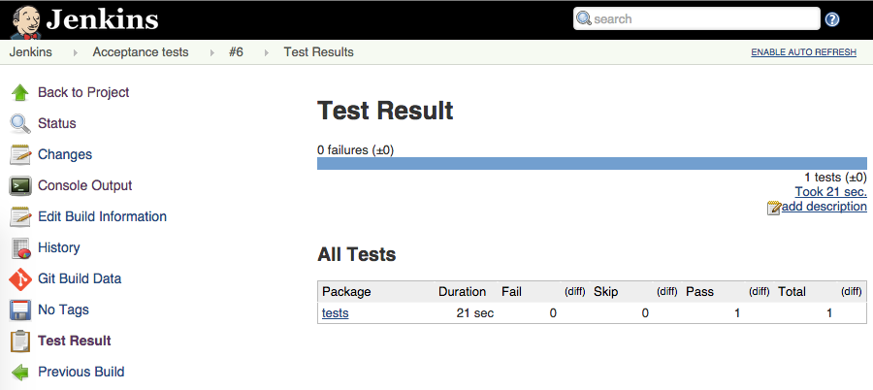](http://testdetective.com/wp-content/uploads/2015/09/Screen-Shot-2015-09-24-at-15.33.05.png)

**Continue reading**  
If you want to continue reading and expand your knowledge in area of  Jenkins and Continuous Integration, I recommend you these books:

* [Continuous Delivery: Reliable Software Releases through Build, Test, and Deployment Automation](https://www.amazon.com/gp/product/0321601912?tag=testdetective-20) – classic! There’s only a few books that really change my mindset of software development process, and this is the most important one. Complete guide to Continuous Integration and Continuous Deployment, must have not only for software testers but for modern software engineers in general

### How to customize TestNG Report

TestNG reporting is quite handy but still sometimes we need some less data in reports or want to display reports in some other format like pdf, excel etc. or want to change report's layout.

There can be two ways we can customize TestNG report

* Using ITestListener Interface:
* Using IReporter Interface: